# NETPAY - INTERVIEW - WE NEED TO GET THAT!

**About me:**

* Hello, my name is anastasis I am an MSc student in Cyber Security at the University of Southampton
* BSc degree was obtained from UoM - first class - computer science / finance
* Java, Python, C and SQL languages
* I came to the UK to expand my knowledge in the field of Security. I believe that there is a need of people that know and understand of security concepts.
* I can describe myself as a person that can adapt quickly in new environments, I am fast learner, and I can collaborate efficiently in a team
* I don’t want to focus on my grades, but I believe that represents the high-quality results I want to achieve in my work.
* I was a basketball team captain for more than 3 years and I know how to motivate my team to achieve its goals through efficient communication.
* I love working in an agile approach where the interaction with clients is continuous and I believe is the more efficient way to achieve high client satisfaction and high-quality deliverables.
* In addition, I know how important is to take accountability of your actions in the security field and my experience from Greek army gave the opportunity to acquire this skill and because more mature. I learnt to make decisions to solve complex problems and keep an eye on details. under pressure

**About company:**

Revolution is NetPay’s award winning - reporting, analytics, provisioning service that offers the capability to the users to have access to valuable information related to both in person and online transactions.

* Game-changer technology
* offer to your clients an advantage against the competitors
* PAX A920 mobile payment terminal from PAX.

green payments strategies shows my company's environmental awareness which is very important nowadays

I understood that Net pay is a company that offers the opportunity to advance my career. I am not a person that will stay on my comfort zone. I want to explore new opportunities and learn new things I know that Netpay can offer me this working environment and I believe that I can give back value to your company. Agile environment

social cycle

work-life balance

**The role**

Since I will be a graduate in a couple of months, I think that your graduate role is a great fit. From the role description I understood that you give attention to security and my background can support the requirements. During my MSc I learned a variety of different vulnerabilities and learn how to raise awareness related to security aspects. + security standards

We focused a lot of secure software development and how we can achieve that. It is very worrying that the last decades form example SQL injections still on the top of the most frequent vulnerabilities that indicates lack of knowledge and security awareness in the software development field.

**1. Secure Development**

**The idea: The earlier in the SDLC a security concern is addressed, the less effort and cost is ultimately required to achieve the same level of security**. (proactively and not reactively)

**Requirement’s phase**: In this stage, developers should identify security requirements and make use of "abuse cases" to interrogate the system and to minimise systems vulnerabilities.

**Static code** **analysis** before executing their application in a live environment to solve the main security problems in coding phase. - programming errors such as syntax and coding standards violation and finding undefined values

**dynamic code** **analysis** offers a more realistic approach to facing security gaps in real-time situations by integrating third-party software components

**Vulnerability assessment**: is mostly automated and focuses on finding potential and known vulnerabilities on the network or an application level

**Pen testing**: in the contrary is no automated, requires the use of tools and an extremely experienced person to conduct it

**Patch management** is very significant and should be executed systematically and when new changes are made in the application.

**2. OWASP - MOST COMMON VULNERABILITIE**

**SQL Injection**: The name is a clear definition of the attack. So, the problem is that users' input is not sanitized, and developers do not use prepared statements/parameterised queries. Therefore, attackers through their input can manipulate the query and cause problems to the db such as delete records or all the table or get unauthorised access.

* [Retrieving hidden data](https://portswigger.net/web-security/sql-injection#retrieving-hidden-data), where you can modify an SQL query to return additional results.
* 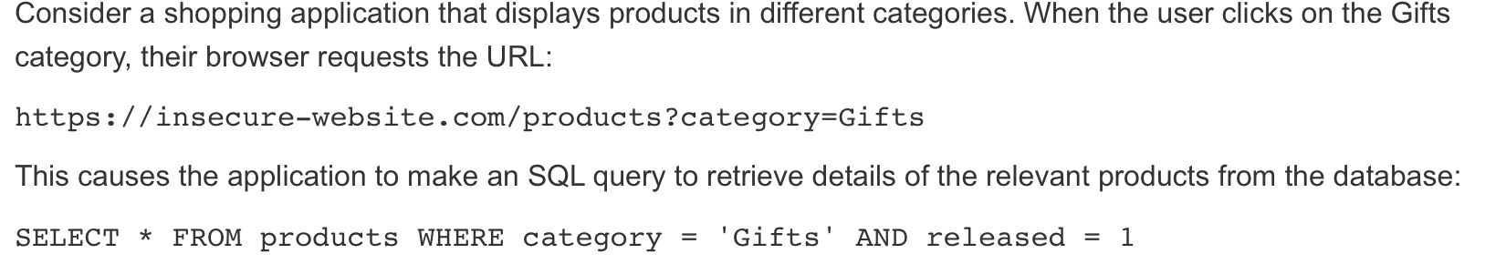
* [Subverting application logic](https://portswigger.net/web-security/sql-injection#subverting-application-logic), where you can change a query to interfere with the application's logic.
* 
* [UNION attacks](https://portswigger.net/web-security/sql-injection/union-attacks), where you can retrieve data from different database tables.
* [Examining the database](https://portswigger.net/web-security/sql-injection/examining-the-database), where you can extract information about the version and structure of the database.
* [Blind SQL injection](https://portswigger.net/web-security/sql-injection/blind), where the results of a query you control are not returned in the application's responses.

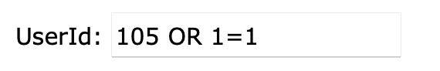 usernames and passwords in a database

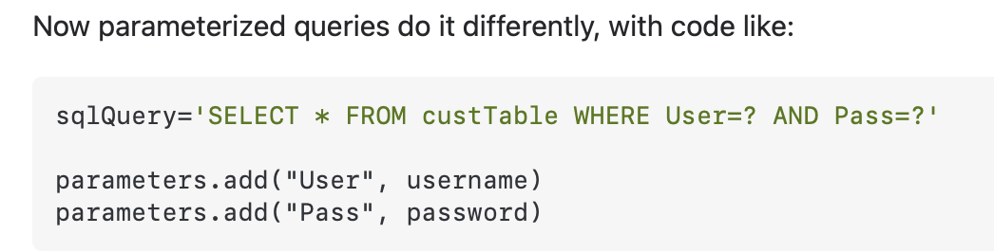

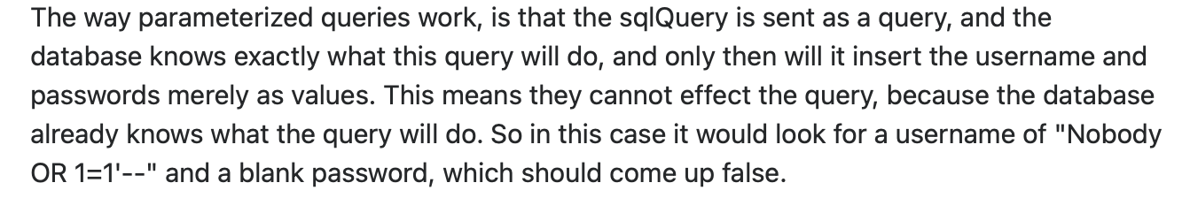

**Insecure Upload**: Developers do not check the files before uploading them and store them in the server. This is catastrophic, the file can have a script inside that might download extra malware and create a remote reverse shell on the server.

**Internal Information**: We should not return error messages to the users that shows internal information. An example is the error stack traces that might be returned by fault.

**Out-Of-Date Software**: one of the most important issues. There are databases that inform people about vulnerabilities. So, if your software is not up to date and there is a security gap then it is very possible to be hacked since many people know the vulnerability.

**CSRF vulnerability**: Application does not use unique tokens to protect the forms and there are GET requests that change the state of the site. Firstly, the requests that change state in a website should be POST and include a random token and we should link the action with users cookie

**Authorisation Bypass:** Normal users had access to the admin area and were able to modify posts, comments, users and other valuable assets of the web application

**XSS Vulnerability**:

* **Reflected XSS**, where the malicious script comes from the current HTTP request.  
  It arises when an application receives data in an HTTP request and includes that data within the immediate response in an unsafe way. 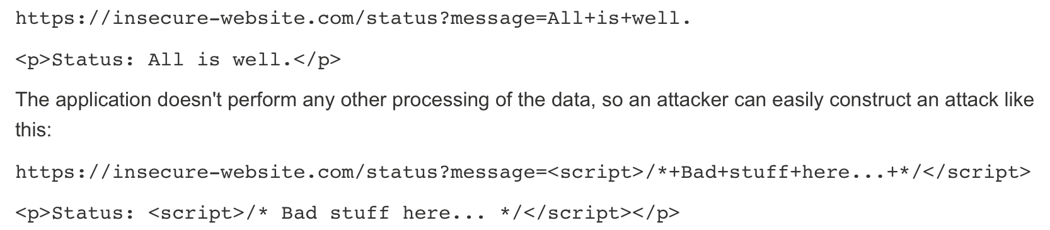
* **Stored XSS**, where the malicious script comes from the website's database.
* arises when an application receives data from an untrusted source and includes that data within its later HTTP responses in an unsafe way.  
  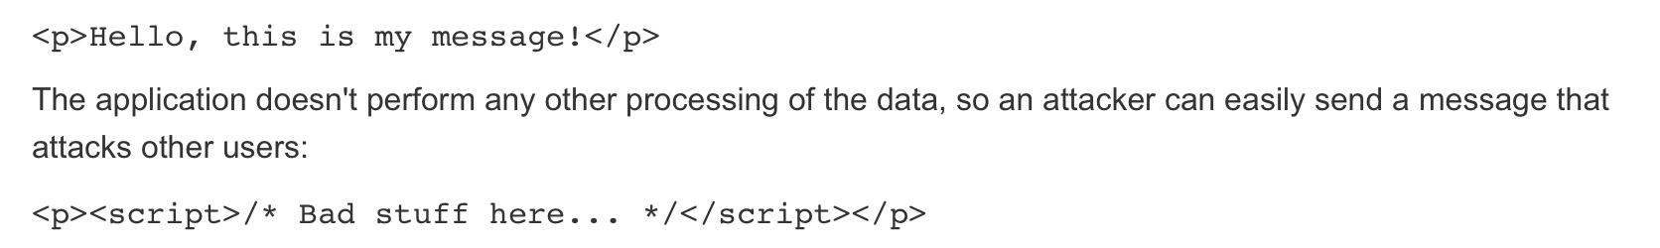
* **DOM-based XSS**, an application contains some client-side JavaScript that processes data from an untrusted source in an unsafe way, usually by writing the data back to the DOM.  
  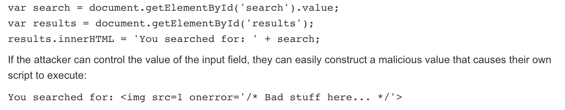
* Read any data that the user is able to access.
* Capture the user's login credentials.
* Perform virtual defacement of the web site.

**PCI DSS Level 1. - depends on the number of transactions**

**The Payment Card Industry Data Security Standard (PCI DSS)**

was created to set globally measures to prevent attacks and enhance data security. Therefore, companies do not need to be compliant with only visa or Mastercard requirements we avoid redundancies and re doing the same work for deferent entities they create this standard

PCI DSS is not governmental legislation it is an industry regulation. This is a significant difference for example with GDPR

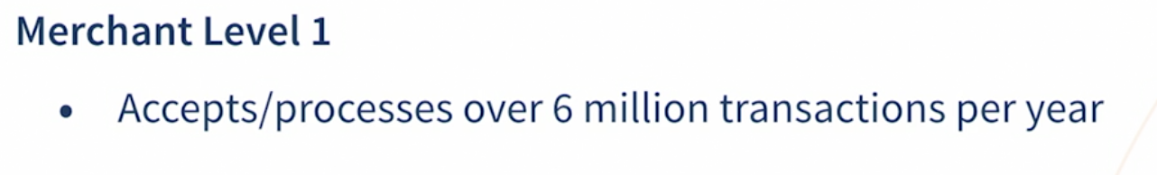

**Who does PCI DSS apply to? - Which parts of your business!!**

Businesses needs to reduce the scope to identify in which parts of the business PCI DSS is applied. To identify these components, we need to ask ourselves if an entity **stores, processes and/or transmits cardholder data (CHD) and/or sensitive authentication data (SAD)** [or is this entity connected to any component that do these activities] if not we can remove it.

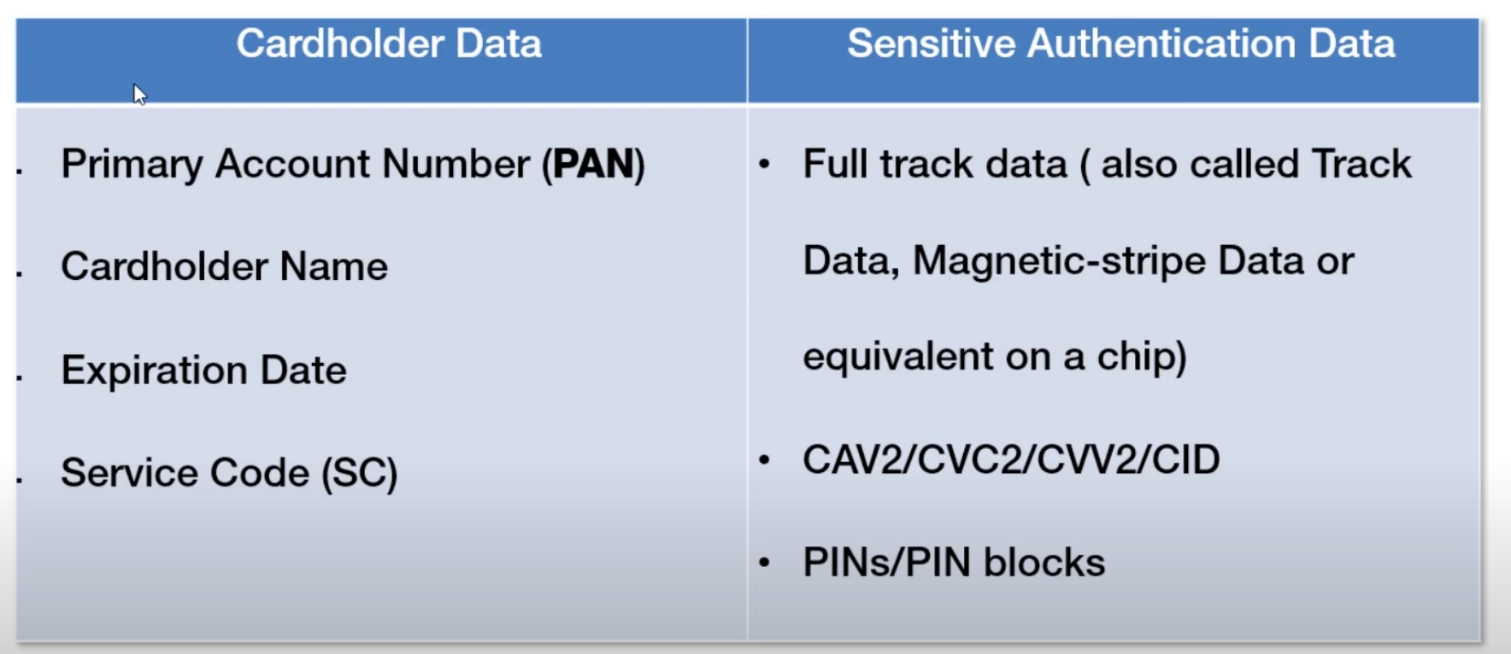

**pan** -> 16 digits card number

**service code** is embedded in the magnetic stripe

**full track data** -> part fo magnetic stripe examples: identify your bank, what is your pin, payment brand etc.

**What can we store according to PCI DSS?**

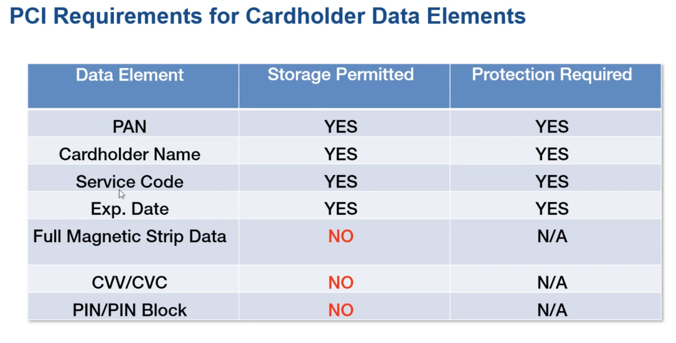

if we store the NO columns then we are not compliant with PCI DSS. Therefore, we **DONT STORE SENSITIVE AUTHENTICATION DATA**

**HOW PAYMENT PROCESS ENVIRONMENT WORKS**

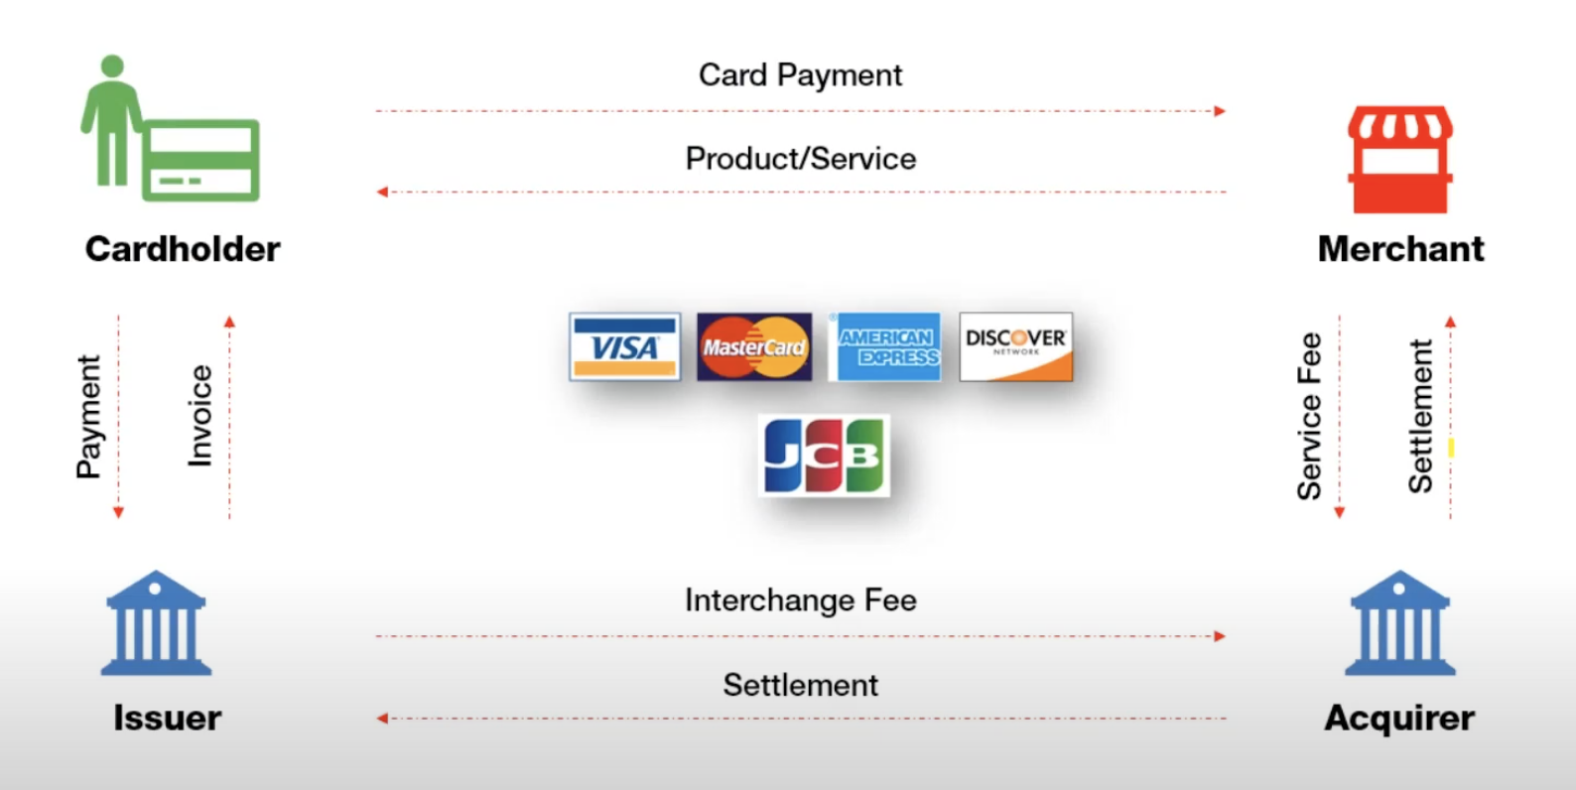

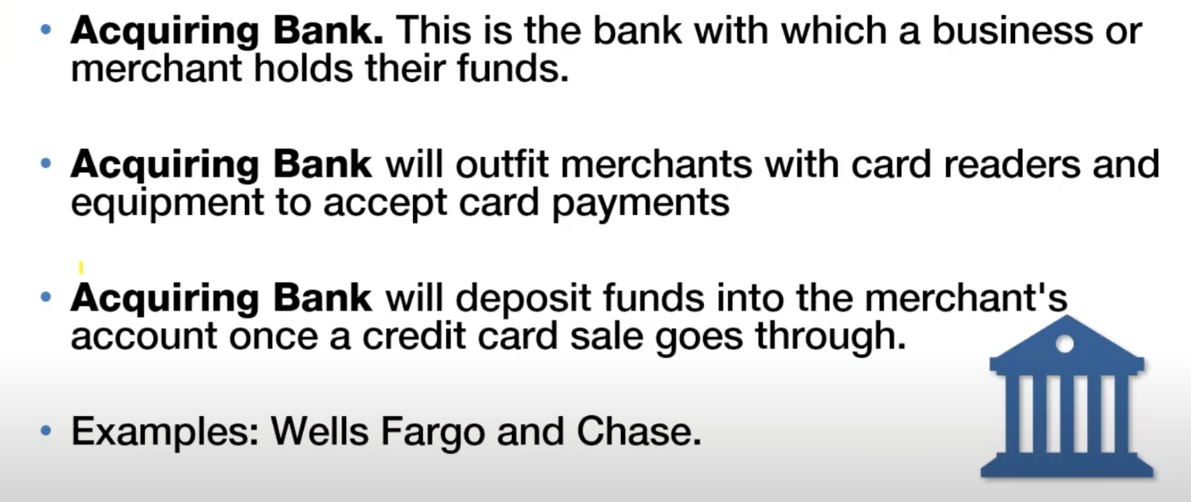

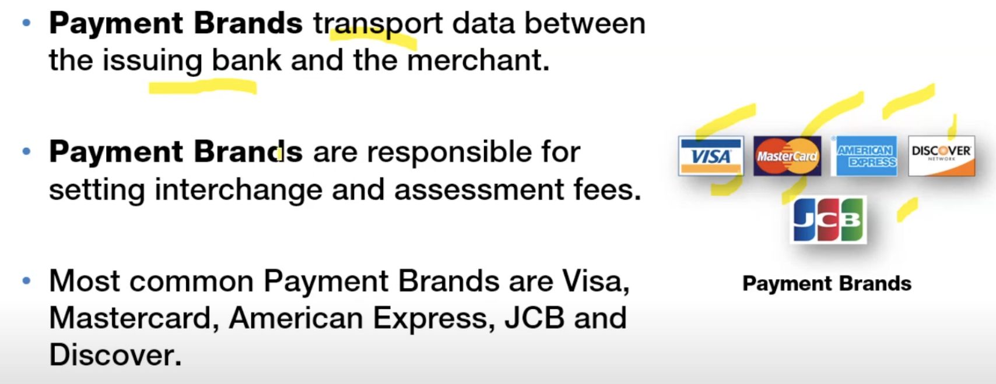

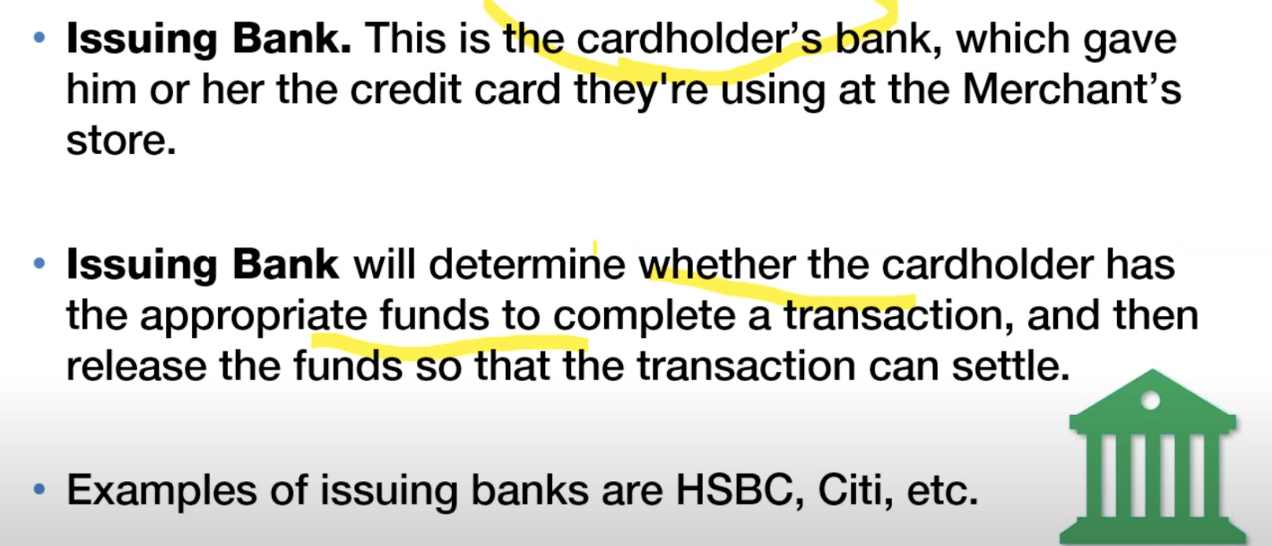

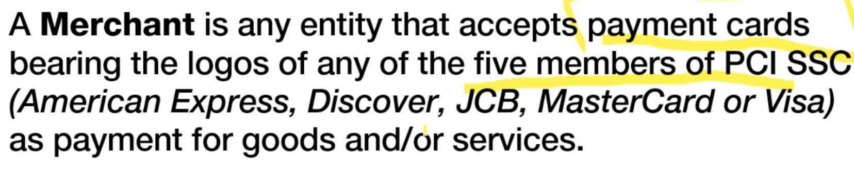

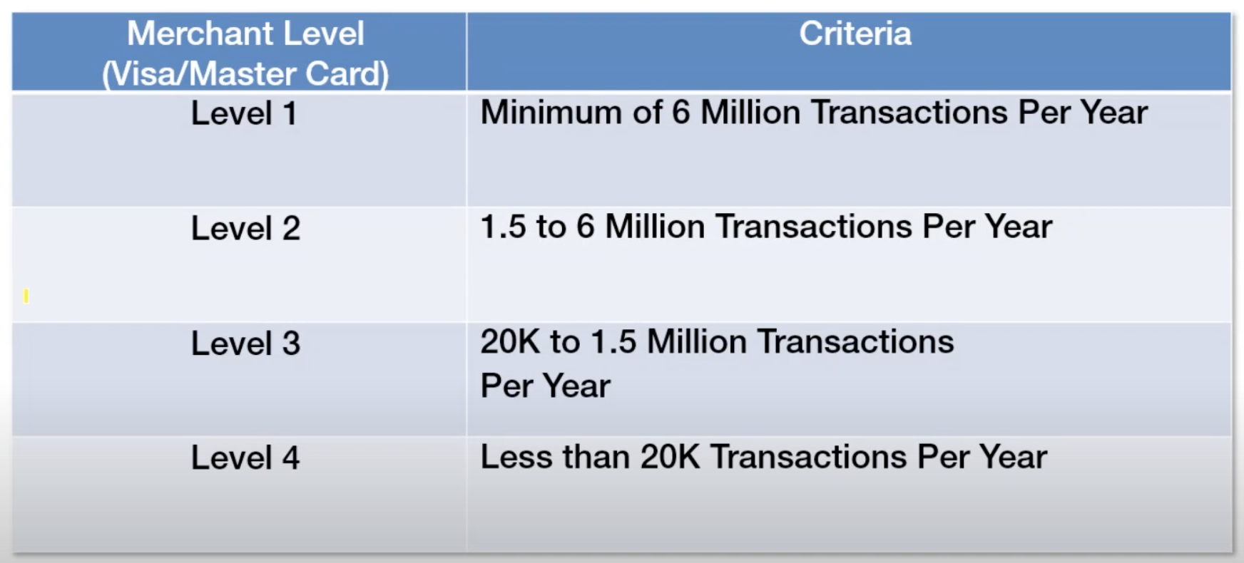

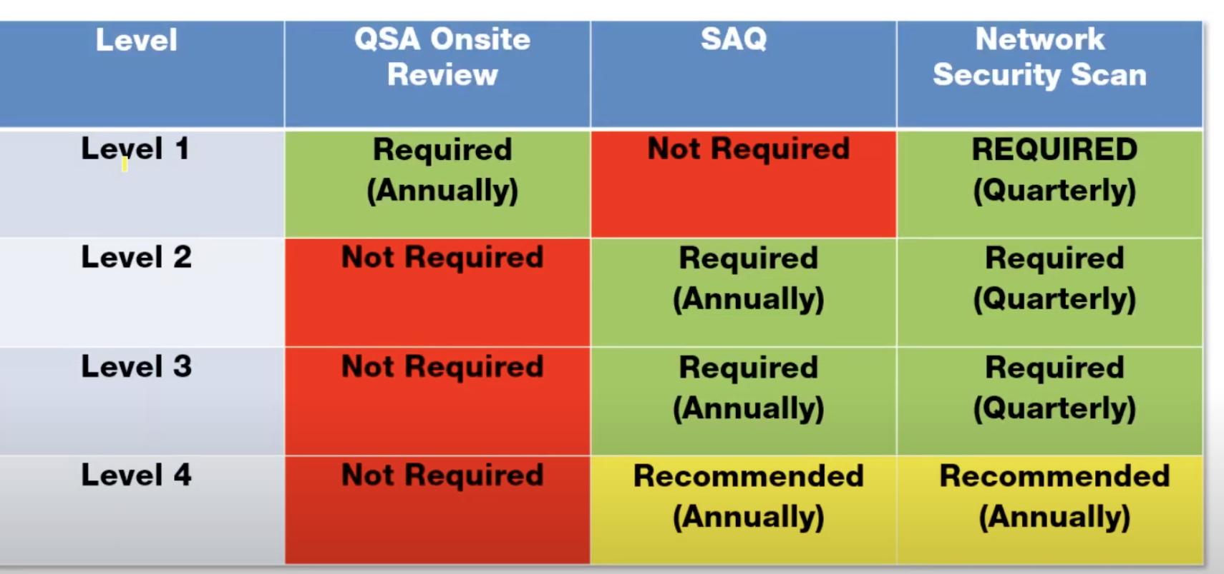

have an obligation to align with the PCI DSS is you working with card payments

**VALIDATION TECHNIQUES:**

* Annual Onsite Assessment
* Quarterly Network Scan conducted by an Approved Scanning Vendor (ASV)
* PEN TESTING ANUALLY

PCI DSS provides a baseline if technical and operational requirements designed to protect account data.

**STEPSSSS!!!!!!**

**AUTHORIZATION**

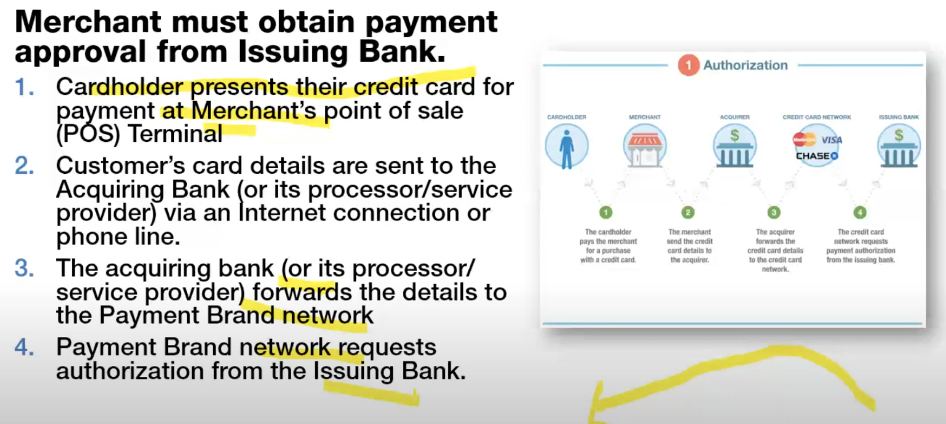

**AUTHENTICATION**

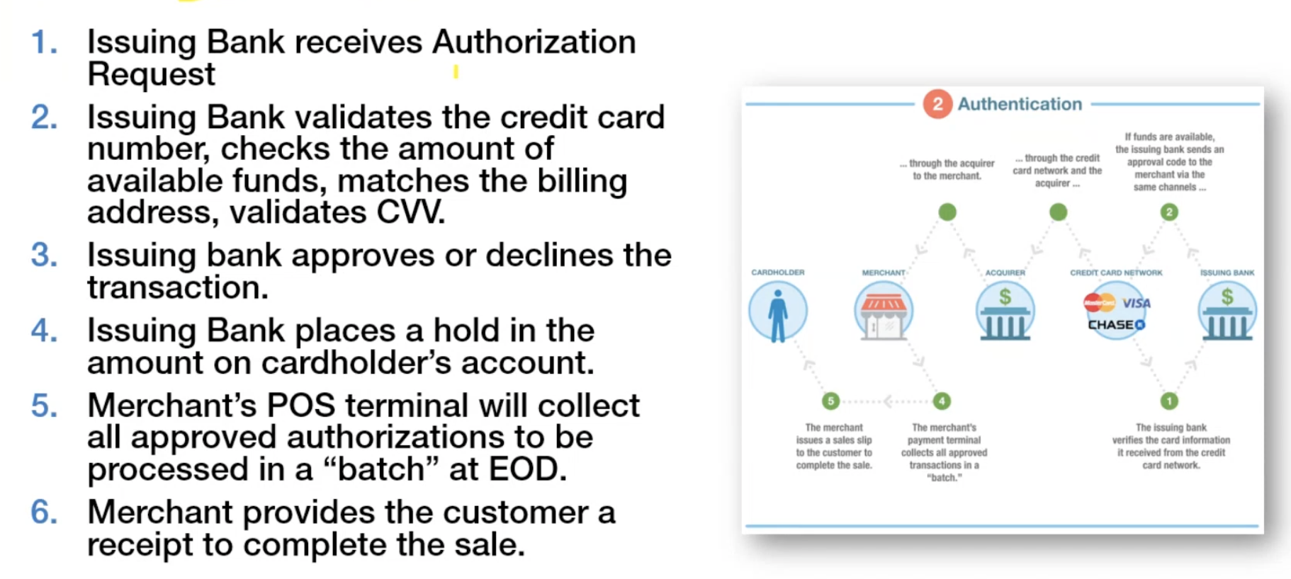

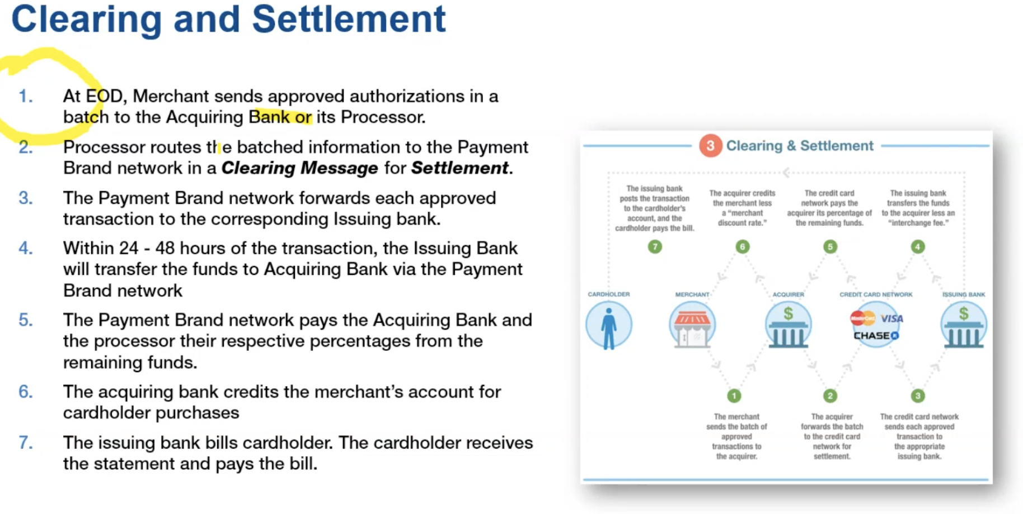

6 PCI DSS requirements goals

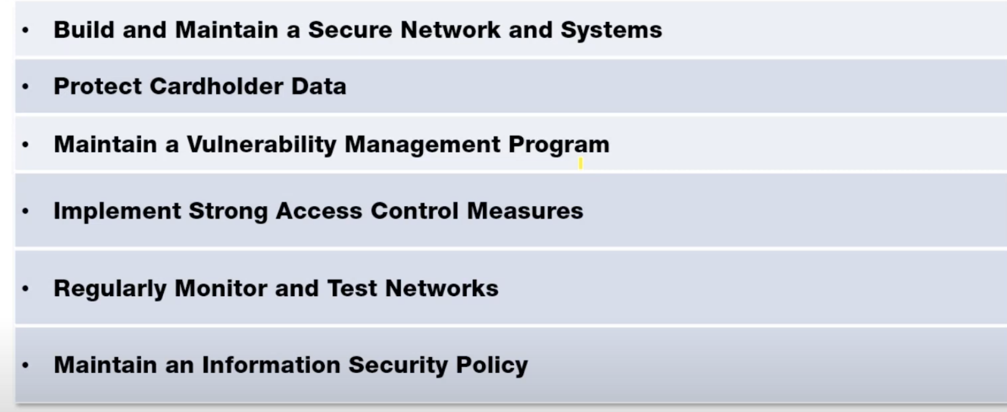

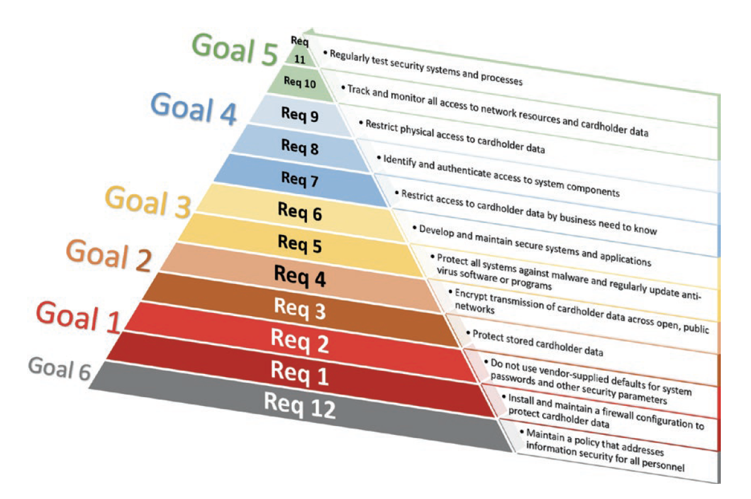

* **Requirement 1: Layering the Network**: Filtering traffic as it passes between trusted and internal network zones, ensuring that the firewalls and routers (or their equivalent) are appropriately configured
* **Requirement 2: Secure by Design/Default**: In the event that your network gets compromised, this is essential for reducing the available attack surfaces for the attacker by removing unnecessary services, functionality, and user accounts and by changing insecure vendor default settings on supporting system components.
* **Requirement 3: The Vault:** Encryption, Tokenization to mitigate an attack that compromise your system
* **Requirement 4: Secure in Motion:** cardholder data and sensitive authorization data should be encrypted also in transit not only at rest
* **Requirement 5: Entry Search**: Malware detection techniques, Static/dynamic analysis, antivirus
* **Requirement 6: Build and Maintain:** Ensure that all security vulnerabilities are mitigated against, in a timely manner, based upon their criticalities, helping prevent attacker’s ability to use known vulnerabilities to gain privileged access to systems.
* **Requirement 7: Role-Based Restrictions**: Role based access control - Ensure critical data can only be accessed by authorized personnel, systems, and processes based upon the strict need to know/need to access requirements for their role
* **Requirement 8: Logical Entry Control:** Consequently, each individual should be assigned their own strong access credentials, which are never shared and are only known to themselves. Logical access restrictions can be further enhanced through the use of additional defensive measures (Multi-Factor Authentication (MFA)), which requires another “independent” factor to authenticate the user.
* **Requirement 9: Physical Entry Control:** Not all attacks occur in the IT systems, and opportunist attackers will seek to profit from gaining physical access to the systems and media that contain CHD or support the payment card operations.
* **Requirement 10: Monitor and Detect**: Having all requirements 1–9 and 12 in place, it is critical for effective monitoring to be in place to ensure that you are able to identify and respond to malicious or unapproved activities
* **Requirement 11: Assurance Testing:** Think of this section as having periodic internal and external patrols to provide independent assurance that all requirements 1–10 and 12 are still active and effectively safeguarding your payment card operations, seeking to identify poor practices, poor configurations, or exploitable vulnerabilities
* **Requirement 12: 3 Ps (People, Policies, and Processes):** well organised team with a military approach and an individual was expected to know the role of a rank above and a rank below and senior management and leadership support.

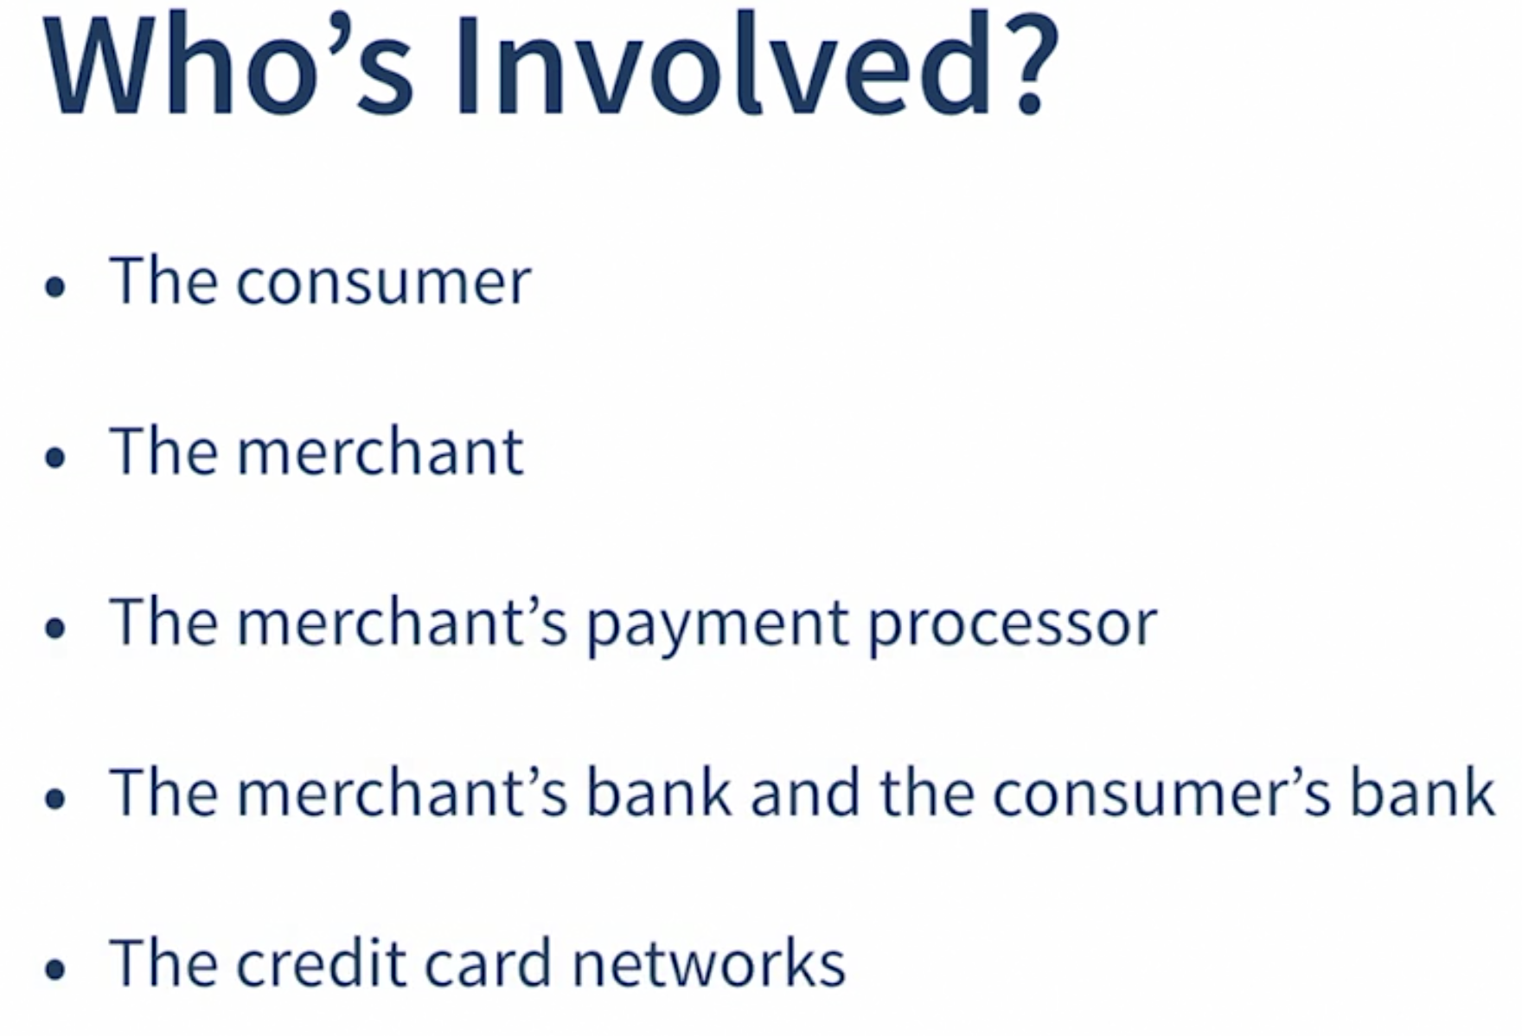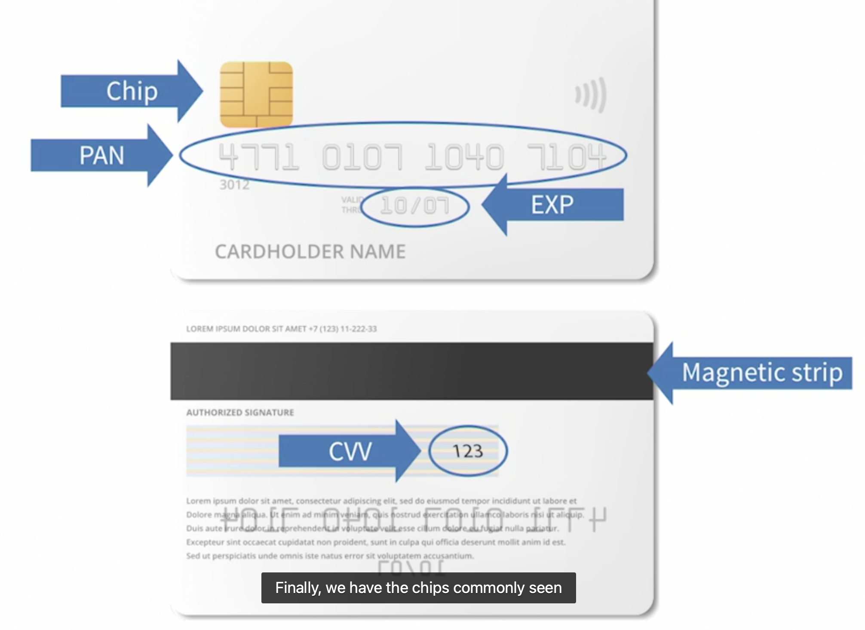

**Unix File System**

* Logical method of organizing and storing large amount of information.
* It is a tree-like structure

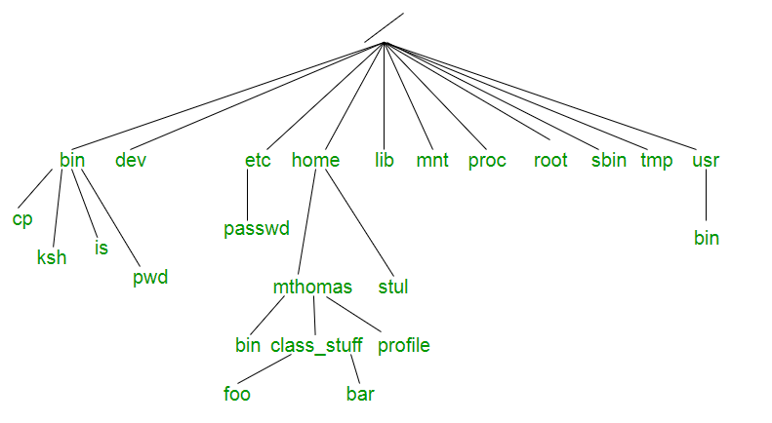

* On the top is the **root** (/) and all the other directories and files are descendants
* **/bin :** Stands for “binaries” and contains certain fundamental utilities, such as ls or cp, which are generally needed by all users.
* **/boot :** Contains all the files that are required for successful booting process.
* **/dev :** Stands for “devices”. Contains file representations of peripheral devices (mouse, keyboard)
* **/etc :** Contains system-wide configuration files and system databases. Originally also contained “dangerous maintenance utilities” such as init, but these have typically been moved to /sbin or elsewhere.
* **/home :** Contains the home directories for the users.
* **/lib:** Contains system libraries, and some critical files such as kernel modules or device drivers.
* **/media :** Default mount point for removable devices, such as USB sticks, media players, etc.
* **/mnt :** Stands for “mount”. Contains filesystem mount points. These are used, for example, if the system uses multiple hard disks or hard disk partitions. It is also often used for remote (network) filesystems, CD-ROM/DVD drives, and so on.
* **/proc :** procfs virtual filesystem showing information about processes as files.
* **/root :** The home directory for the superuser “root” – that is, the system administrator. This account’s home directory is usually on the initial filesystem, and hence not in /home (which may be a mount point for another filesystem) in case specific maintenance needs to be performed, during which other filesystems are not available. Such a case could occur, for example, if a hard disk drive suffers physical failures and cannot be properly mounted.
* **/tmp :** A place for temporary files. Many systems clear this directory upon startup; it might have tmpfs mounted atop it, in which case its contents do not survive a reboot, or it might be explicitly cleared by a startup script at boot time.
* **/usr :** Originally the directory holding user home directories,its use has changed. It now holds executables, libraries, and shared resources that are not system critical, like the X Window System, KDE, Perl, etc. However, on some Unix systems, some user accounts may still have a home directory that is a direct subdirectory of /usr, such as the default as in Minix. (on modern systems, these user accounts are often related to server or system use, and not directly used by a person).
* **/usr/bin :** This directory stores all binary programs distributed with the operating system not residing in /bin, /sbin or (rarely) /etc.
* **/usr/include :** Stores the development headers used throughout the system. Header files are mostly used by the **#include** directive in C/C++ programming language.
* **/usr/**lib : Stores the required libraries and data files for programs stored within /usr or elsewhere.
* /var : A short for “variable.” A place for files that may change often – especially in size, for example e-mail sent to users on the system, or process-ID lock files.
* /var/log : Contains system log files.
* /var/mail : The place where all the incoming mails are stored. Users (other than root) can access their own mail only. Often, this directory is a symbolic link to /var/spool/mail.
* /var/spool : Spool directory. Contains print jobs, mail spools and other queued tasks.
* **/var/tmp :** A place for temporary files which should be preserved between system reboots.

Classification of Unix system

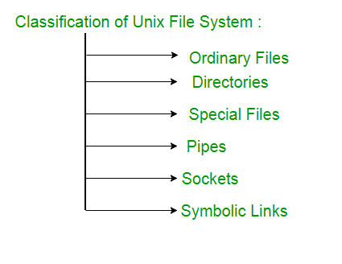

* **Ordinary files** – An ordinary file is a file on the system that contains data, text, or program instructions.
* **Directories** – Directories store both special and ordinary files
* Special Files – Used to represent a real physical device such as a printer, tape drive or terminal, used for Input/Output (I/O) operations
* **Pipes** – UNIX allows you to link commands together using a pipe. The pipe acts a temporary file which only exists to hold data from one command until it is read by another
* **Symbolic Link –** Symbolic link is used for referencing some other file of the file system. Symbolic link is also known as Soft link. It contains a text form of the path to the file it references
* **Sockets** - it is a stream of data, very similar to network stream (and network sockets), but all the transactions are local to the filesystem

**Passwords in unix** were originally stored in /etc/passwd (which is world-readable), but then moved to /etc/shadow (and backed up in  /etc/shadow-) which can only be read by root (or members of the shadow group).

The password are salted and hashed. The default formats are MD5-crypt, bcrypt, sha256-crypt, sha512-crypt, and for historical reasons DES (note DES only allows 8-byte passwords). Note, sha512-crypt is typically involves 5000 rounds of SHA512-ing the password and the number of rounds is configurable.

**Unix Operating System**

To control and manage computer hardware, software resources, and Operating system is required for the computer

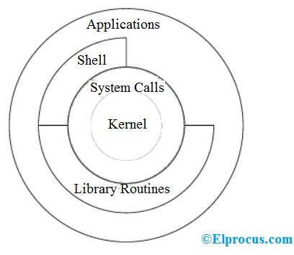

The architecture of this operating system is four layered

For this operating system, **Kernel** is the central core that interacts directly with the hardware of the system. some functions of the Kernel are:

* Computer hardware such as memory, disc, printers
* The kernel schedules the processes

**System calls** acts as the interface between the kernel and other libraries

**Shell**: It is the interface between the user and the kernel. Users can interact with the shell using shell commands. There are various commands and utilities which you can make use of in your day-to-day activities. cp, mv, cat and grep,

**Application**:

Advantages of Unix:

* **Multiuser accessing simultaneously**
* **Multi-tasking:** It provides the facility to run multiple programs or processes by multiple users on one system.
* Requests and commands given by the user are carried out by the kernel and shell together
* It also provides **easy** **maintenance** of the files

# **Top 50 Software Engineering Interview Questions and Answers**

https://www.guru99.com/software-engineering-interview-questions.html

**What is computer programming?**

It gives us a readable language that allows us to implement an algorithm which is turned to machine code which a computer can understand.

**What are variables?**

Variables are addresses in memory that keep some data and the programme knows that if wants to acquire variable's data will go to check the related address memory. In addition, in programming languages such as C where we can have a lower-level interaction with variables by create references we need to be very careful not to create memory leaks that will lead to full our RAM and freeze our device.

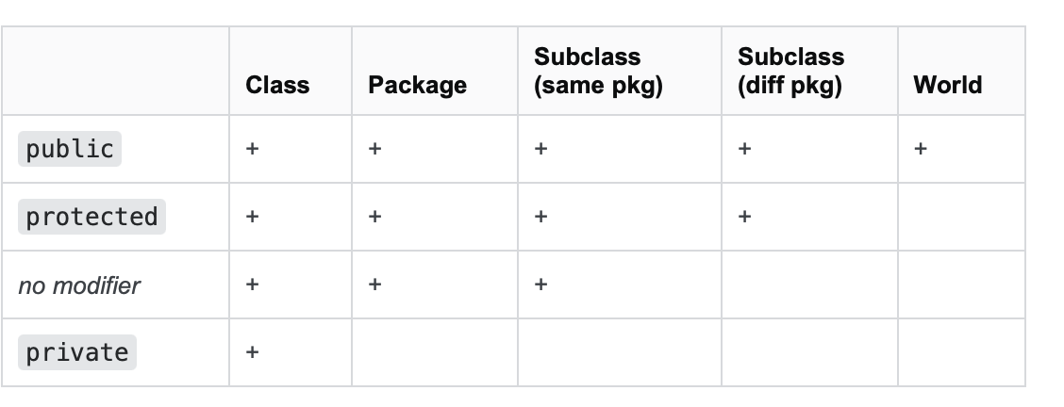

**Heap Vs Stack**

Application memory is separated into **4 level**, the area where the **code-instruction** is stored, the area where **static** and **global variables** are stored, the **stack** and the **heap**

In the stack we store function calls and local variables. Therefore, during execution of the application if a function is called will be stored in the stack until it finished and if the function **calls another function, then the second function will be stored** in the stack and the first function will wait until the second finished its execution.

**Unlike stack application heap is not fixed.** its size can vary during runtime. the app can control the size, can have as much as it possible according to the system and to store variavles or arrays on the heap we need to use malloc on C.

In java things are different since we have the JVM. There are some optimizations in the JVM that may even use the Stack for Objects, this reduces the garbage collection effort.

**java: Classes are stored on a special part of the heap**

**Stack overflow:**

When the allocated stack to our application become full because we call many functions or we have written a bad code of a recursive function then the program will crash since the stack will run out of memory. **Stack does not grow during runtime!!**

**What is JVM?**

**JVM (Java Virtual Machine) is an abstract machine** that provides a runtime environment in which Java bytecode can be executed. It can also run those programs which are written in other languages and compiled to Java bytecode.

**The JVM performs the following main tasks:**

* Loads code
* Verifies code
* Executes code
* Provides runtime environment

**What is JRE?**

Java run time environment is a set of software tools which are used for developing Java applications. It is used to provide the runtime environment where we implement JVM contains a set of libraries + other files that JVM uses at runtime.

**What is the JDK?**

Java Development Kit is a software development environment which is used to develop Java applications and applets. The JDK contains a private Java Virtual Machine (JVM) and a few other resources such as an interpreter/loader (java), a compiler (javac), an archiver (jar), a documentation generator (Javadoc), etc. to complete the development of a Java Application.

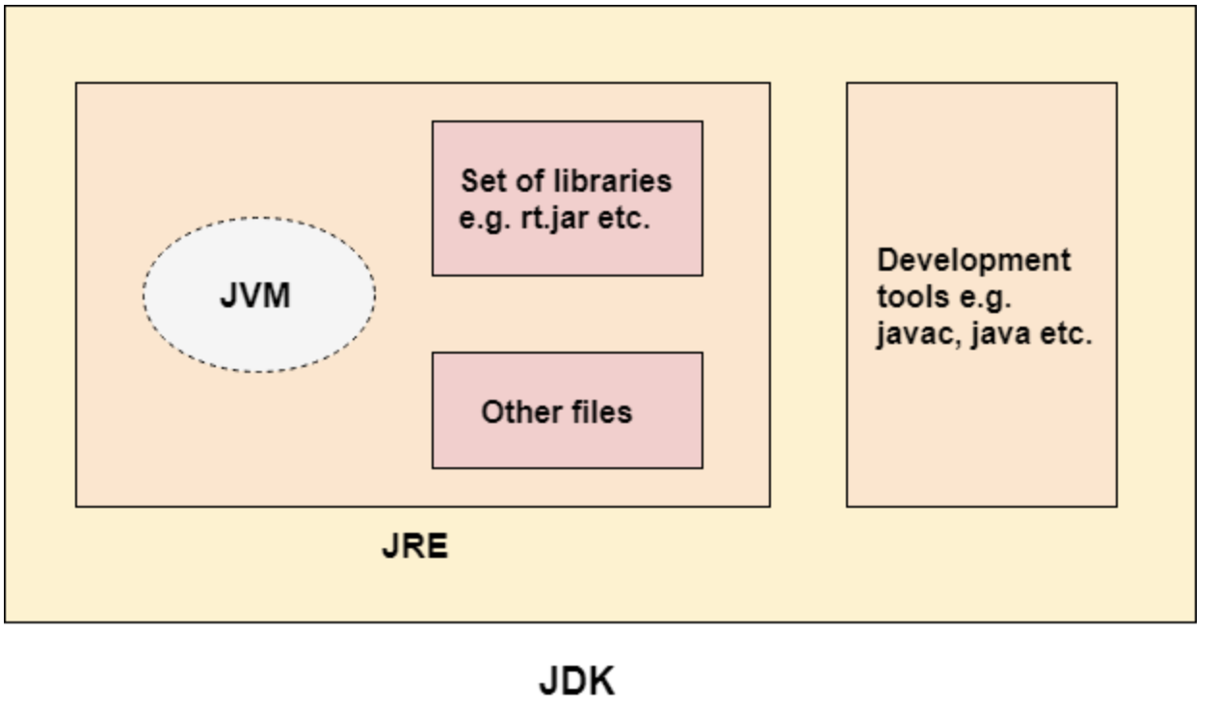

**Static variable**

A variable which is declared as static is called static variable. It cannot be local. You can create a single copy of static variable and share among all the instances of the class. Memory allocation for static variable happens only once when the class is loaded in the memory.

**Data Types**

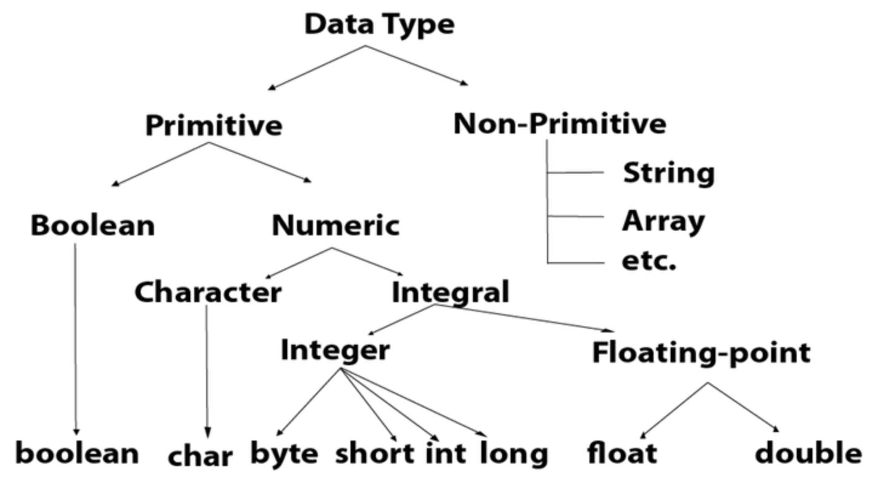

**What are constants in programming and why are they used?**

Constant is a variable that is unchangeable during runtime. We use them when we want to have a value such as a web address from which we get our data to be unchangeable. Also in a teamwork project the others can see that the variable should not be changed.

**What is an algorithm and what are its features?**

An algorithm is a set of instructions designed to perform a specific task. The main features are:

* clear
* efficient (as little as possible CPU and RAM usage)
* finite (φαιναιτ) -> we have an input and output, and it is clear to everybody

**3 Types of programming errors and their implications**

* **runtime error**: The application running, and you get a crash. Error in code such as trying to access an array position that does not exist or forget to handle exceptions. The implication of runtime error bad user experience, bad feedback
* **Logical error**: Bad algorithms do that, bad organised coding. The programme runs bad returns weird output. Implications bad reviews
* **Syntax errors**: This type of error is recognised during compiling and most of the times exist because of unfamiliarity with a specific language. Not serious implications maybe delay.

**What is unit testing and why it is important?**

Unit testing involves testing individual components of the software program or application. The main purpose behind this is to check that all the individual parts are working as intended. A unit is known as the smallest possible component of software that can be tested.

**Advantages**: Reduces Defects in the Newly developed features or reduces bugs when changing the existing functionality. Reduces Cost of Testing as defects are captured in very early phase. Improves design and allows better refactoring of code

**JUnit how it works?**

Junit provides APIs to conduct the test and the class we want to test is called subject under test

1. create tet class

2. create test methods and parametrised test methods to test many different inputs

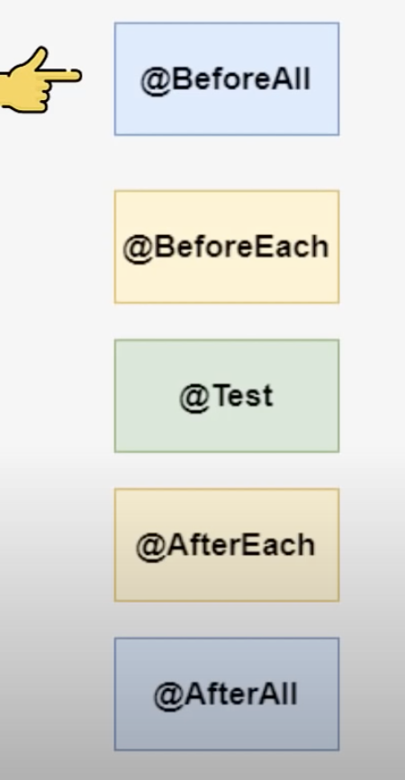

3. Conditional execution depends let’s say on the OS

4. assumpions are the actuall test for example for specific valeus

**Low level vs high level languages in programming?**

Compliers and interpreters are programs that help convert the high-level language (Source Code) into machine codes to be understood by the computers. Computer programs are usually written on high level languages

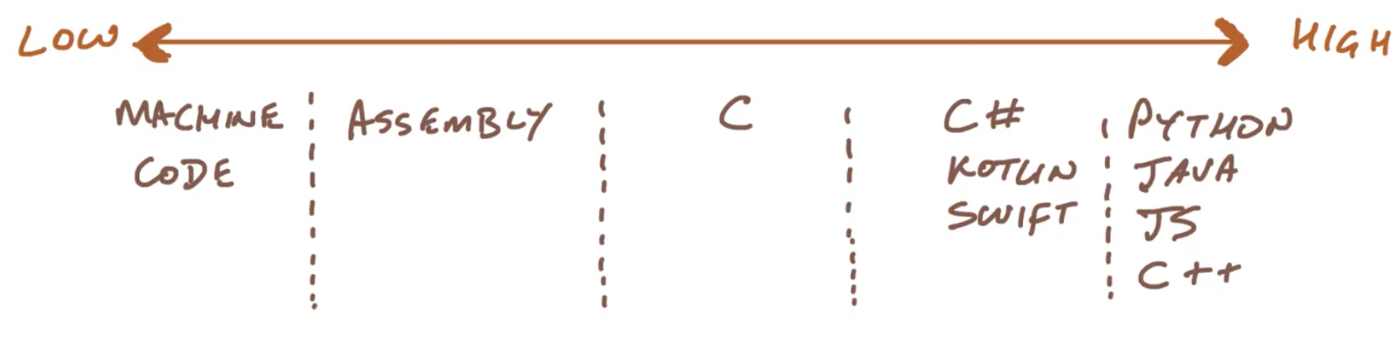

**Compiler VS Interpreter**

**compiler** -> transform programming language into machine code at build time

**interpreter** -> as you are running the programme it creates machine code on the fly. In that way we can run the same programme in different systems without needed to compile it for different machines.

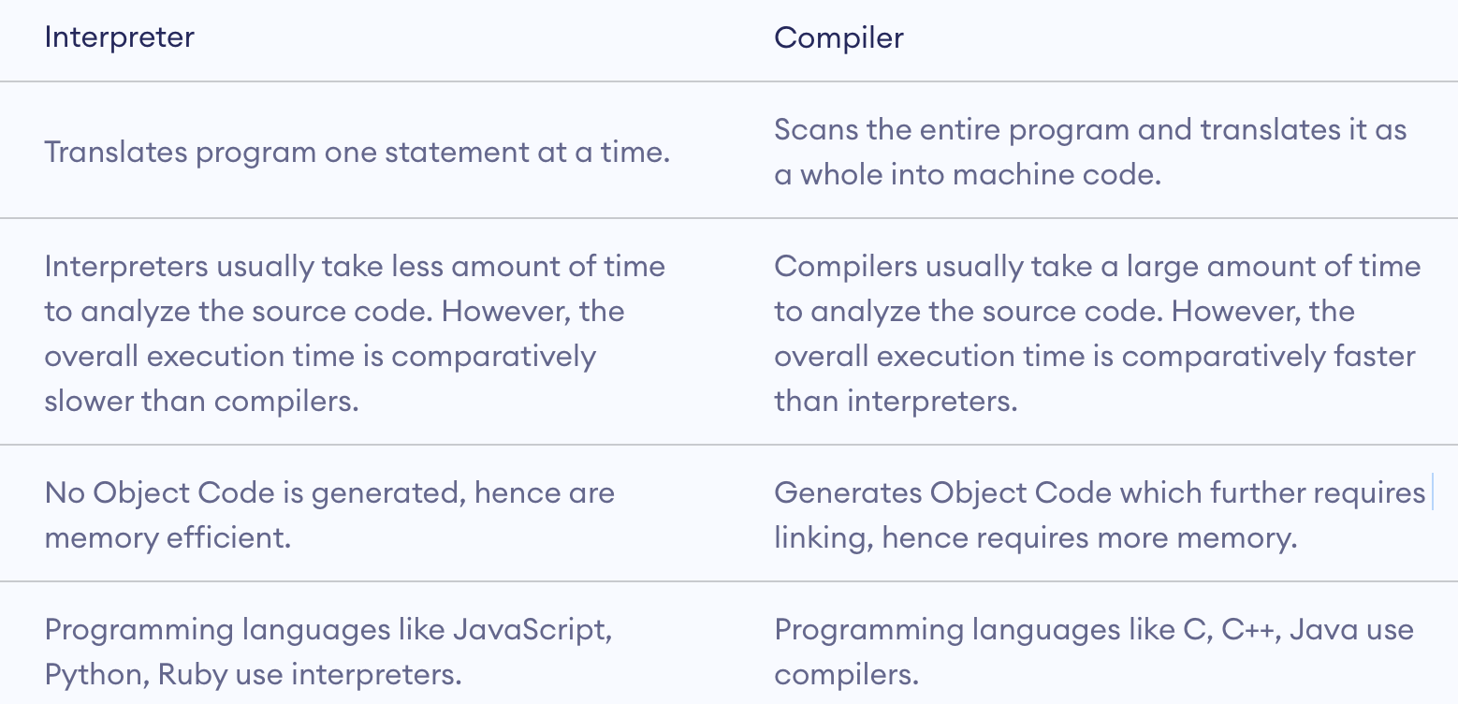

**What is an array in programming and what is it for?**

If you want to group a set of variables that have the same type, then arrays are the best option. **An array is a contiguous segment of memory.** Let’s say we want to display a set of music titles in a user then we are going to use an array to display them all together

**Arrays VS Lists**

**Arrays:** Accessing an element on an array has constant time equal to O(1) because if we know the base address of the arrays then we just add the index multiple by the number of bits needed for the type of data we store.

* You need to know the fixed size.
* Insert item in the beginning O(n) because we need to move all the elements
* Insert in the end O(1)
* Average case O(n)

**Linked List**: They have nodes, and each node stores the data and the address of the next node (link field). The time complexity of accessing an item is O(n) n=number of items. because in average case you will need to traverse the n/2 items to find the item you want. The base or head of the linked list points on the first element and the last element the link field points to null. It is a dynamic list you can add elements. It is better when your data are big in size because you do not keep extra space without reason like arrays. You need extra 4 bytes for the pointer in each node.

* Insert item in the beginning O(1) because just add new node that links to the previous first and the head points to the new node
* Insert item in the end O(n) needs to traverse all the list
* Average case O(n)

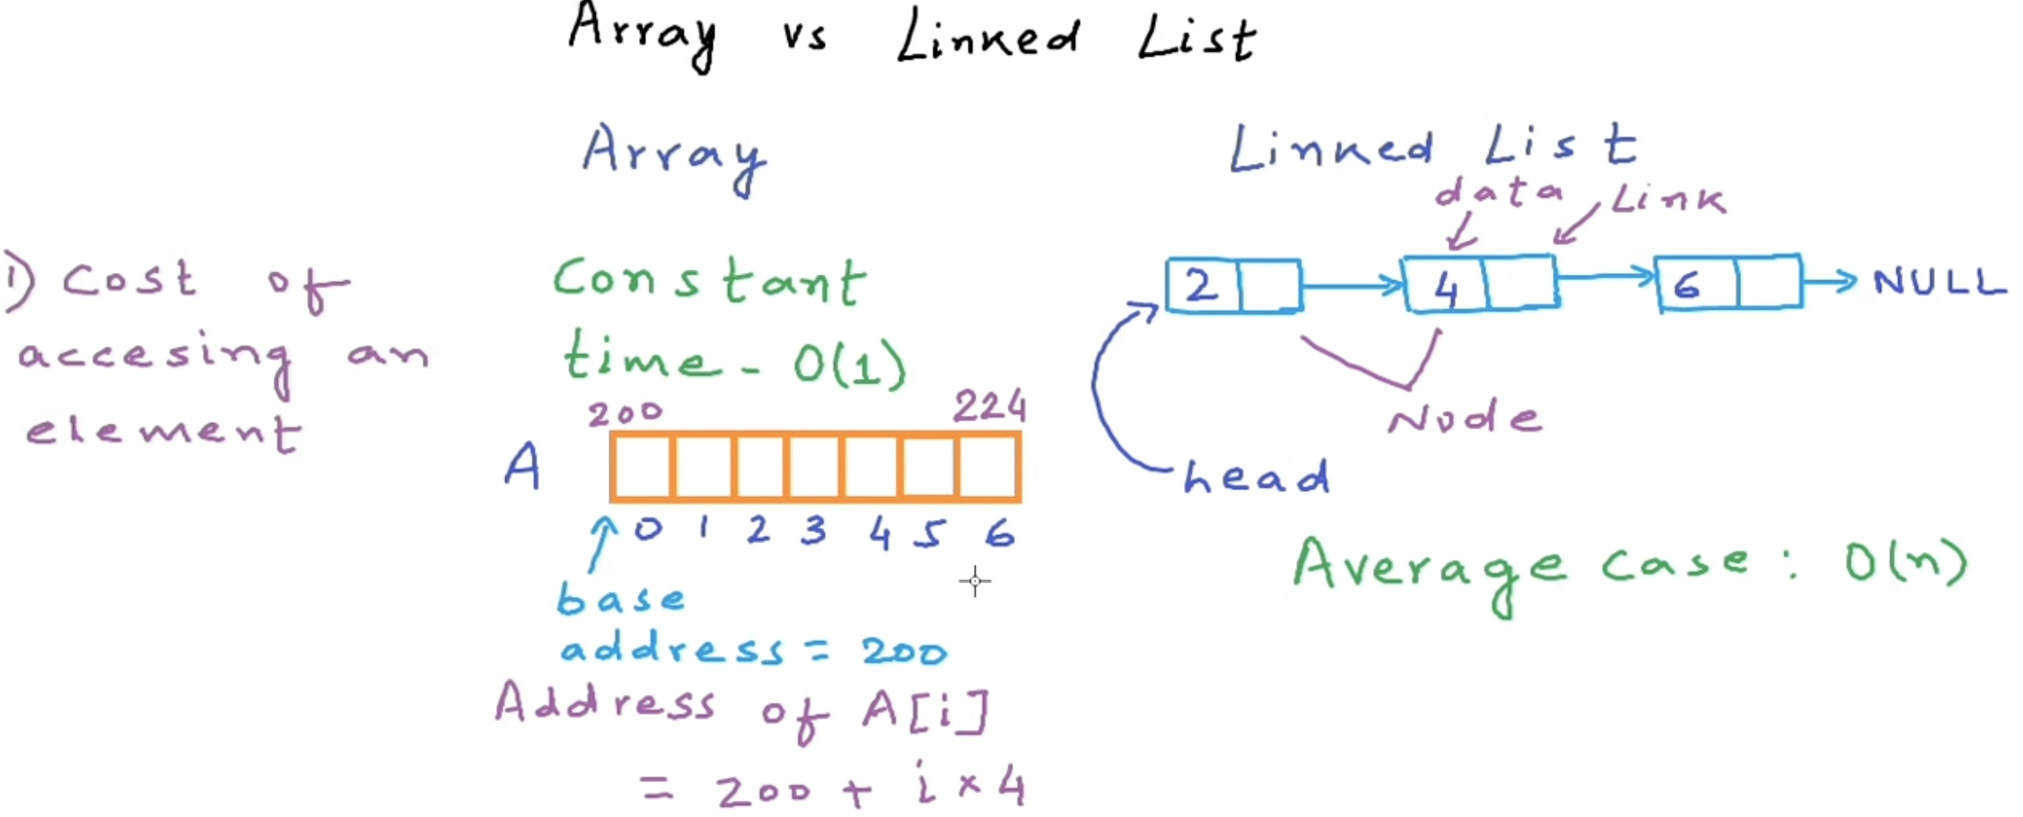

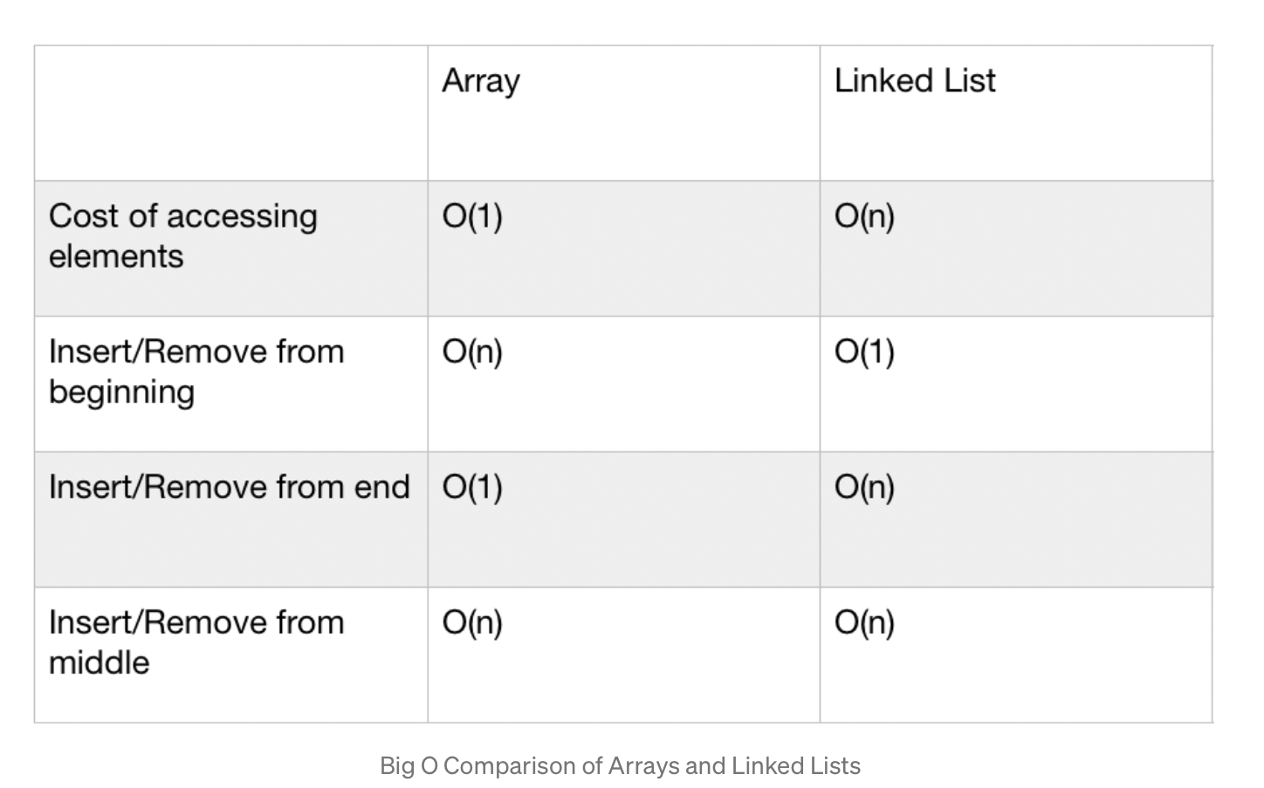

* **Singly linked list** — Traversal of items can be done in the forward direction only.
* **Doubly linked list** — Traversal of items can be done in both forward and backward directions. Nodes consist of an additional pointer known as **prev**, pointing to the previous node.
* **Circular linked lists** — Linked lists where the prev pointer of the head points to the tail and the next pointer of the tail points to the head.

**How can we improve search in an array?**

**Binary search -** required sorted array, then each time you reduce the size of the array by half.

**What is a stack**

Stack is a linear data structure which follows a particular order in which the operations are performed. The order may be LIFO (Last In First Out)

* **Push**: Insert an element on to the top of the stack.
* **Pop**: Delete the topmost element and return it.
* **Peek**: Return the top element of the stack without deleting it.
* **isEmpty**: Check if the stack is empty.
* **isFull**: Check if the stack is full.

**What is a queue?**

A Queue is a linear structure which follows a particular order in which the operations are performed. The order is First in First Out (FIFO). **The difference** between stacks and queues is in removing. In a stack we remove the item the most recently added; in a queue, we remove the item the least recently added.

* **Enqueue: Insert an element to the end of the queue.**
* **Dequeue: Delete the element from the beginning of the queue.**

**What is Hash tables?**

A Hash Table is a data structure that stores values which have keys associated with each of them. Furthermore, it supports lookup efficiently if we know the key associated with the value. Hence it is very efficient in inserting and searching, irrespective of the size of the data.

Let a hash function H(x) maps the value x at the index **x%10 (hash function**) in an Array. For example if the list of values is [11,12,13,14,15] it will be stored at positions {1,2,3,4,5} in the array or Hash table respectively.

**Binary Search Trees**

A binary search tree exhibits a unique property that distinguishes it from other trees. This property is known as the binary-search-tree property. Let x be a node in a binary search tree.

* If y is a node in the left subtree of x, then y.key ≤ x.key
* If y is a node in the right subtree of x, then y.key ≥ x.key

1. key: The value stored in the node.
2. left: The pointer to the left child.
3. right: The pointer to the right child.
4. p: The pointer to the parent node.

**DATA STRUCTURES**

https://towardsdatascience.com/8-common-data-structures-every-programmer-must-know-171acf6a1a42

**What are operators in programming?**

Operators performs an operation to some data

**Arithmetic. + / - : )**

**Assignment** operator =

**Logical** operators (and or not)

**Relational** **operators** ( < > == !=)

++there are also some others that I used them after some research such as shift operator that shift the bits to the left

**What is a loop?**

In computer science, a loop is a programming structure that repeats a sequence of instructions until a specific condition is met

**What is the top-down design approach?**

Top-down design is the name given to breaking a software down into increasingly smaller manageable parts (also known as decomposition) that we can work on them and then bring them back all together to have the final project

**Method overloading?**

If a class has multiple methods having same name but different in parameters, it is known as Method Overloading.

**Method overriding?**

If subclass (child class) has the same method as declared in the parent class, it is known as **method overriding in Java**.

**Super keyword?**

The super keyword in Java is a reference variable which is used to refer immediate parent class object.

The super keyword can also be used to invoke the parent class constructor. Let's see a simple example:

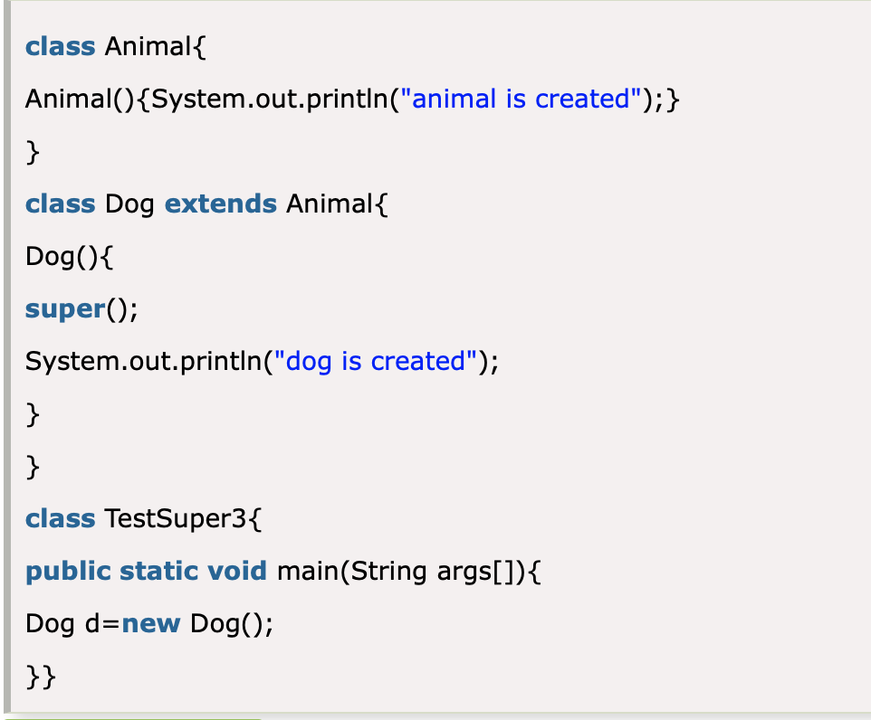

**Final keywork java?**

final variable cannot change value constant

final method cannot be override

final class cannot be extended.

**DRY vs WET in programming**

In wet approach you write everything from scratch each time therefore you need more time and effort. In dry approach you can use a function and call the function each time you want to do a specific activity. More clean code, easy maintainable - better

**WET = right everything twice**

**DRY = Don't Repeat Yourself**

**What is a bubble sort? When should we use it?**

**O(n2) -> not good....**

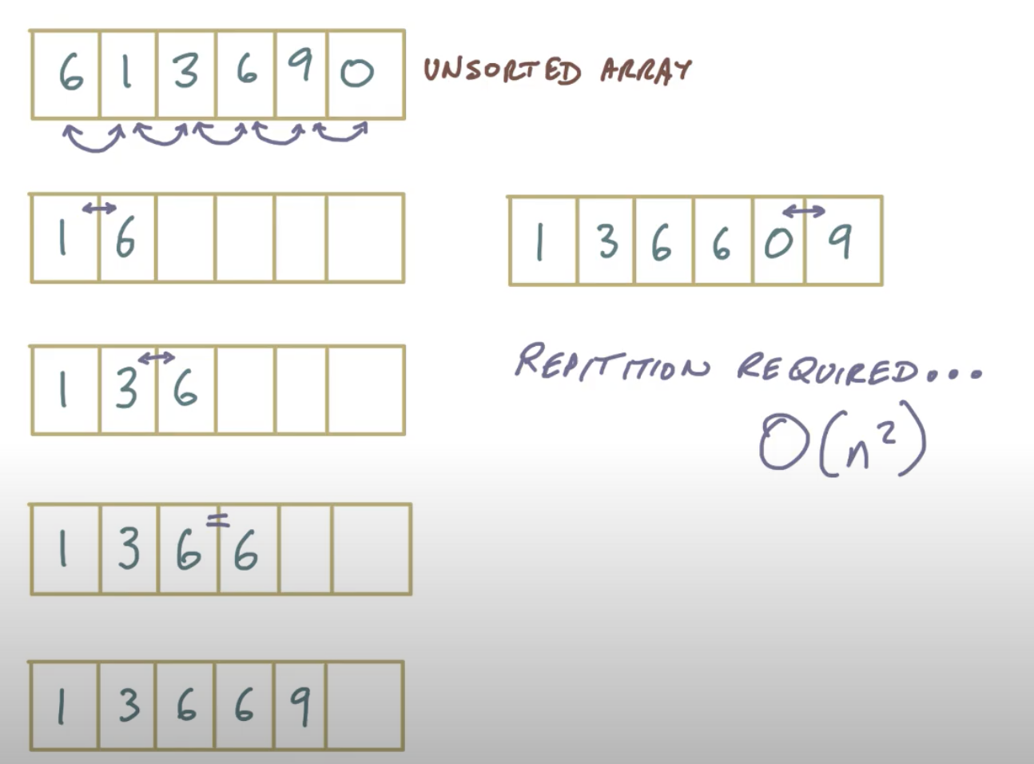

**Synchronous VS Asynchronous code**

In other words, you need to wait for a task to finish to move to the next one. In asynchronous operations, on the other hand, you can move to another task before the previous one finishes

Let’s say that you want to fetch some data from a server.

If the process is long or undetermined then it is not good to use synchronous code because the app will be freeze until the data are returned. In these cases, we need to use asynchronous methods.

**What is a class? What is an object?**

**A class** is a template for objects. A class defines object properties including a valid range of values, and a default value A class also describes object behaviour.

**An object** is a member or an "instance" of a class. An object has a state in which all of its properties have values that you either explicitly define or that are defined by default settings.

**Abstraction** Data abstraction is the process of hiding certain details and showing only essential information to the user. Abstraction can be achieved with either abstract classes or interfaces

* **Abstract class:** is a restricted class that cannot be used to create objects (to access it, it must be inherited from another class).
* **Abstract method:** can only be used in an abstract class, and it does not have a body. The body is provided by the subclass (inherited from
* // Abstract class
* abstract class Animal {
* // Abstract method (does not have a body)
* public abstract void animalSound();
* // Regular method
* public void sleep() {
* System.out.println("Zzz");
* }
* }
* // Subclass (inherit from Animal)
* class Pig extends Animal {
* public void animalSound() {
* // The body of animalSound() is provided here
* System.out.println("The pig says: wee wee");
* }
* }
* class Main {
* public static void main(String[] args) {
* Pig myPig = new Pig(); // Create a Pig object
* myPig.animalSound();
* myPig.sleep();
* }
* }

**Inheritance**

Inheritance can be defined as the process where one class acquires the properties (methods and fields) of another. With the use of inheritance, the information is made manageable in a hierarchical order.

The class which inherits the properties of other is known as subclass (derived class, child class) and the class whose properties are inherited is known as superclass (base class, parent class).Inheritance gives the ability to get all the properties, methods and functions from one parent class and pass them to a child class. advantage not to write twice the same thing WEP

**Polymorphism**

**The word "poly" means many and "morphs" means forms**

Very important concept. So lets say we have child class from a parent class. and all of these classes inherit a method. However, we want for each subclass the method to be more specific.

***contextualize* our inherited** “sound( )” function.

There are two types of polymorphism in Java: compile-time polymorphism and runtime polymorphism. We can perform polymorphism in java by method overloading and method overriding.

**Encapsulation**

it is also known as data hiding. In encapsulation, the variables of a class will be hidden from other classes and can be accessed only through the methods of their current class - **private variables getters setters**

**Benefits of Encapsulation**

* The fields of a class can be made read-only or write-only.
* A class can have total control over what is stored in its fields.

**Volatile keyword** is used to modify the value of a variable by different threads. It is also used to make classes thread safe. It means that multiple threads can use a method and instance of the classes at the same time without any problem

**isPalindrome**

**public** **boolean** **isPalindromeReverseTheString**(String text) { StringBuilder reverse = **new** StringBuilder();

String clean = text.replaceAll("\\s+", "").toLowerCase(); **char**[] plain = clean.toCharArray(); **for** (**int** i = plain.length - 1; i >= 0; i--) { reverse.append(plain[i]); } **return** (reverse.toString()).equals(clean);}

# function which return reverse of a string

def isPalindrome(s):

    return s == s[::-1]

# Driver code

s = "malayalam"

ans = isPalindrome(s)

if ans:

    print("Yes")

else:

    print("No")

**Fibonacci**

def F(n):

if n == 0: return 0

elif n == 1: return 1

else: return F(n-1)+F(n-2)

public int fibonacci(int n) {

if (n < 2) return n;

return fibonacci(n - 1) + fibonacci(n - 2);

}

**What are functional and non-functional requirements?**

Functional requirements are functional features which are expected by users from the proposed software product.

Non-functional requirements are related to security, performance, look, and feel of the user interface.

**Searching**: For **searching** element 1, we have to traverse all elements (in order 3, 2, 1). Therefore, **searching** in **binary search tree** has worst case **complexity** of O(n). In general, time **complexity** is O(h) where h is height of **BST**

**Tell me exactly what would happen if you added 1 to the maximum integer in Java?**

**Integer overflow**

And, unfortunately, [most languages and most compilers raise no error at all](https://rosettacode.org/wiki/Integer_overflow) and simply perform a modulo operation, wraparound, or truncation, or they have other undefined behaviour. For the above example, the result is most often 0.

**If I want to send a compressed file securely, shall I encrypt it first and then compress it or vice versa?**

You should compress then encrypt it to reduce the risk of a dictionary attack being performed, and to not hint the attacked that the file is compressed.

**What is the refactoring of code?**

Code refactoring is defined as the process of restructuring computer code without changing or adding to its external behaviour and functionality

**Multiple Inheritance**

a class can inherit properties of more than one parent class. The problem occurs when there exist methods with same signature in both the super classes and subclass

**Java** does not support **multiple inheritance**

**Closures - Javascript**

A **closure** is the combination of a function bundled together (enclosed) with references to its surrounding state (the **lexical environment**). In other words, a closure gives you access to an outer function’s scope from an inner function. In JavaScript, closures are created every time a function is created, at function creation time.

**Merge sort**

O(nlogn) -> we need to visit n items - logn -> maximum hright of the binary tree

def msort2(x):

if len(x) < 2:

return x

result = [] # moved!

mid = int(len(x) / 2)

y = msort2(x[:mid])

z = msort2(x[mid:])

while (len(y) > 0) and (len(z) > 0):

if y[0] > z[0]:

result.append(z[0])

z.pop(0)

else:

result.append(y[0])

y.pop(0)

result += y

result += z

return result

**Quick sort**

With Quicksort, the input list is partitioned in linear time, O(n), and this process repeats recursively an average of log2n times. This leads to a final complexity of O(n log2n).

def sort(array=[12,4,5,6,7,3,1,15]):

"""Sort the array by using quicksort."""

less = []

equal = []

greater = []

if len(array) > 1:

pivot = array[0]

for x in array:

if x < pivot:

less.append(x)

elif x == pivot:

equal.append(x)

elif x > pivot:

greater.append(x)

# Don't forget to return something!

return sort(less)+equal+sort(greater) # Just use the + operator to join lists

# Note that you want equal ^^^^^ not pivot

else: # You need to handle the part at the end of the recursion - when you only have one element in your array, just return the array.

return array

**The software development is a life cycle is composed of the following stages SDLC**

SDLC is the process used by the software industry to design develop and test high quality software. SDLC is a **tried and tested approach** suitable for large scale information systems and relies on the production of **system documentation** and **standards of developments**. It is used to **guide the developers** through the development process because its sequential nature allows to **break a complex system** development process into smaller manageable tasks. However, traditional SDLC models are slow and costly compare to new approaches because of their inflexibility, and the lack of user involvement keep the stakeholders apart from the project’s development. Moreover, today there is an need for the development of information system which handle unstructured data and operate within decision-making environments, which can be support by traditional SDLCs.

* **Planning - Requirement analysis   
   Requirement** **analysis** is the most important and fundamental stage in SDLC. It is performed by the senior members of the team with inputs from the customer. customers probably believe they know what the software is to do, it may require skill and experience in software engineering to recognize incomplete, ambiguous or contradictory requirements.  
   **Planning** for the quality assurance requirements and identification of the risks associated with the project is also done in the planning stage. **SWOT** ANALYSIS
* **Specification**clearly define and document the product requirements and get them approved from the customer. which consists of all the product requirements to be designed and developed during the project life cycle.
* **Software architecture**The architecture of a software system refers to an **abstract representation** of that system. Architecture is concerned with making sure the software system will meet the requirements of the product, as well as **ensuring that future requirements can be addressed.**
* **Implementation**THE ACTUAL CODE IS WRITTEN HERE to meet products' requirements
* **Testing**Testing of parts of software, especially where code by two different engineers must work together, falls to the software engineer.
* **Documentation**An important task is documenting the internal design of software for the purpose of future maintenance and enhancement.
* **Maintenance**Maintaining and enhancing software to cope with newly discovered problems or new requirements can take far

**Scrum**

Scrum is an agile method which can solve complex problems and guide the major tasks during the development process. To organise and achieve that goal, Scrum uses the **sprints**. Sprint is a process pattern that includes **requirements analysis, design, code evolution, testing and delivery**. The number of sprints required for a project depends on the complexity and size of the project. Each Sprint has a predefined **time window (approximately 30 days),** and the team uses a **backlog** that **prioritises** the features that need to be added on the project and add business value to the clients. The product manager assesses the backlog and updates priorities as required. **New changes are not allowed to be introduced during the Sprint**. Therefore, developers can work in a stable environment. At the end of each Sprint, the **security advisor checks** the requirements, the deadlines and possible bugs and create a final security review. In addition, the team has daily brief **Scrum meeting** to inform the **Scrum master** about the process of the project. The Scrum master is the team leader who assesses the feedback, takes the right decisions and tries to uncover potential problems as early as possible. To conclude, **The Scrum process patterns enable a software team to work successfully in a world where the elimination of uncertainty is impossible. SOS**

ISO 27001

* ISO/IEC 27001 is an international standard on how to manage information security.
* Provides specification of information security management systems
* Systematics approach that icludes people, processes and technology
* if you follow it, you will be compliant with GDPR and other governmental legislations
* It focuses on protecting the CIA of data - CONFIDENTIALITY, AVAILABILITY AND INTEGRITY
* 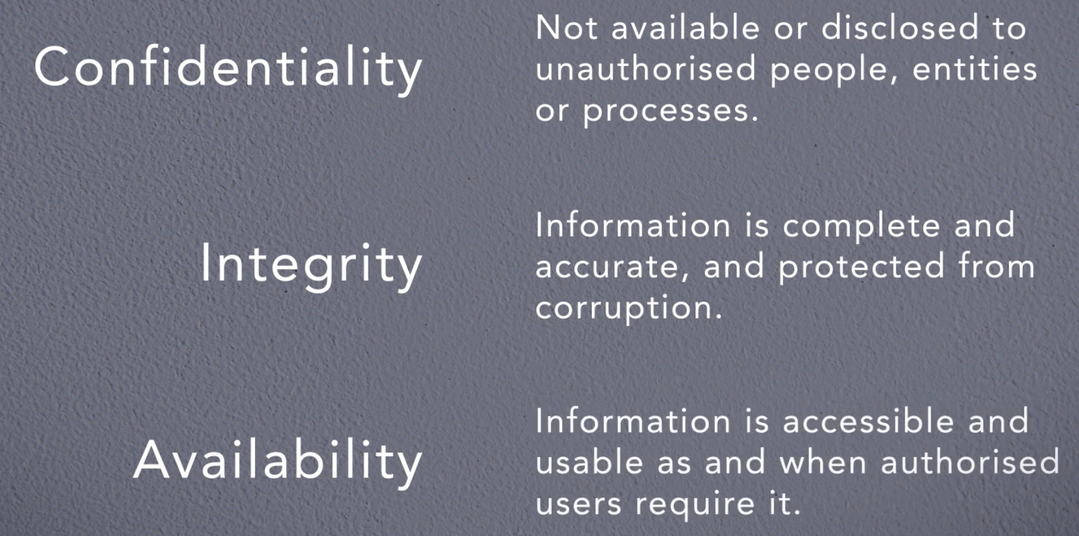
* It can be applied in multiple organisations
* but Needs to remember that ISO2001 provides only the specification. For guidance and best practises during implementation we need also ISO27002

Advantages:

1. Secure your information in all its forms - digital, paper based or stored in the cloud
2. Increase company’s attack resilience
3. Helps protect what it matters in your business and reduce the attacks that are based on technology-based risks or poorly inform employees or ineffective procedures
4. Reduce the cost related to security
5. CIA of your data

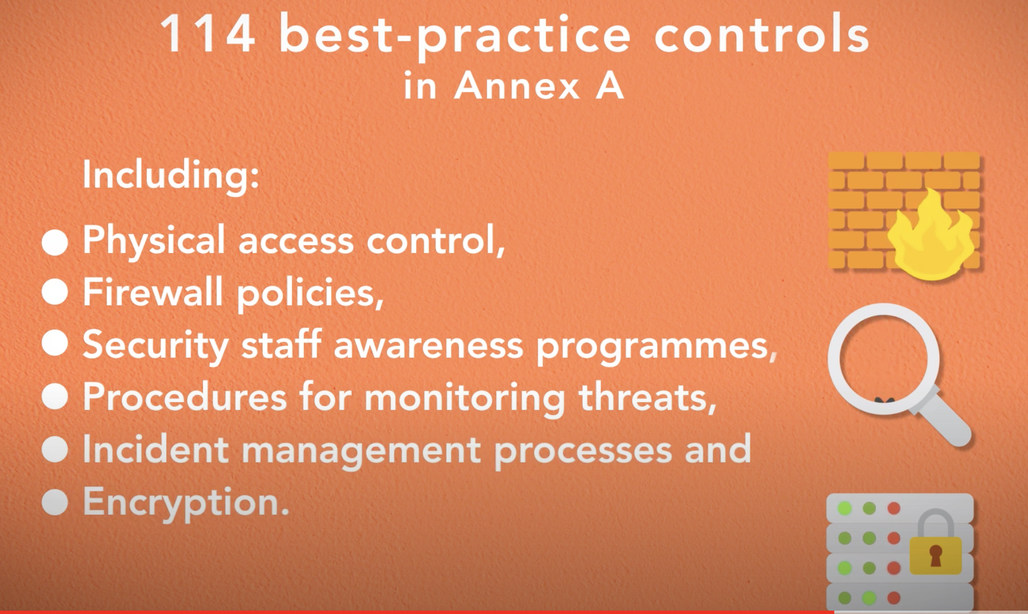

**Cyber essentials**

Main techniques companies should adapt to enhance security. UK released the cyber essentials techniques to protect companies against common cyber threats, but not against advanced attacks such as zero-day vulnerabilities or social engineering. Therefore, cyber essentials do not include the human factor on their context, this is why they are not effective against more sophisticated attacks. Cyber essentials focus only on protection of IT infrastructure

**What are the basic requirements to protect the IT Infrastructure?**

* **Firewalls**  
  are network security devices that can be implemented in hardware, software or firmware or a hybrid solution of them. Depending on their position inside the scope the firewalls accept data flows of network traffic and block some connections that are considered to be malicious or risky. Therefore, possibly dangerous connections are prevented from reaching the cyber assets and reduce the attack surface. Firewalls use rules to block unauthenticated inbound connections and these rules should be documented, validated, and justified. There are 2 types of firewalls:
  + **Boundary Firewall**: Monitoring traffic to and from the scope with many devices
  + **Host-based Firewall**: Monitoring the traffic from a specific device for maximizing security (mostly a software on a device)
* **Secure** **configuration**ensure that computers/devices are configured to reduce vulnerabilities and provide only strictly required services. Default configurations should be checked because they are not always secure, so admins should change default passwords, disable unnecessary services and software and disable auto-run features.
* **User access control**ensure user accounts are assigned to authorised individuals only and provide access to actually required resources **only**. It is a set of processes and techniques to manage accounts and authorisations. If a high privileges account is compromised, then severe damage will be caused. Some techniques to strengthen the AC are:
  + to remove unused accounts
  + Setup a process to create and approve a new user account
  + use two factors authentication
  + always authenticate users before granting access
  + only admin can execute administrative activities
* **Malware protection**restrict execution of known malware and untrusted software. It reduces the risk of damage caused by harmful code which can be originated by email attachments, downloads or directly installation of unauthorized software. The problems that can be caused by malware are very severe such as data leakage or loss or malfunctioning of the system. the countermeasures are:
  + updated anti-malware software which can help with all the known malwares since it identifies them by a signature
  + application whitelisting - a list with the software that is allowed to execute
  + sandbox, isolated and controlled environment to run unknown applications
* **Patch management**ensure devices/software are not vulnerable to known security issues for which fixes are available. Vendors release updates for all supported software. It is important to:
  + keep all software updated
  + Use licenced software and supported!
  + cyber essentials say that up to 14 dates you can wait without updating. However, 14 days are too many.

**What is SWOT analysis?**

SWOT stands for Strengths, Weaknesses, Opportunities, and Threats, and so a SWOT Analysis is **a technique for assessing** these four aspects of your business. You can use SWOT to **reduce the chances of failure** and give an advantage to your organisation by understanding what you're lacking and **eliminating hazards** that would otherwise catch you unawares**. It is suitable to create a strategy that distinguishes you from your competitors**, and so compete successfully in your market.

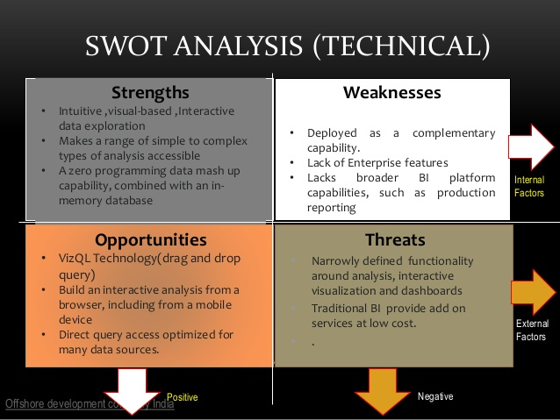

MVC FRAMEWORK

it is an architectural pattern that separates an application into three main logical components: the **model**, the view, and the controller

### **Model**

The Model component corresponds to all the data-related logic that the user works with. This can represent either the data that is being transferred between the View and Controller components or any other business logic-related data

### **View**

The View component is used for all the UI logic of the application. For example, the Customer view will include all the UI components such as text boxes, dropdowns, etc. that the final user interacts with.

### **Controller**

Controllers act as an interface between Model and View components to process all the business logic and incoming requests, manipulate data using the Model component and interact with the Views to render the final output.

## 1×× Informational

* [**100** Continue](https://httpstatuses.com/100)
* [**101** Switching Protocols](https://httpstatuses.com/101)
* [**102** Processing](https://httpstatuses.com/102)

## 2×× Success

* [**200** OK](https://httpstatuses.com/200)
* [**201** Created](https://httpstatuses.com/201)
* [**202** Accepted](https://httpstatuses.com/202)
* [**203** Non-authoritative Information](https://httpstatuses.com/203)
* [**204** No Content](https://httpstatuses.com/204)
* [**205** Reset Content](https://httpstatuses.com/205)
* [**206** Partial Content](https://httpstatuses.com/206)
* [**207** Multi-Status](https://httpstatuses.com/207)
* [**208** Already Reported](https://httpstatuses.com/208)
* [**226** IM Used](https://httpstatuses.com/226)

## 3×× Redirection

* [**300** Multiple Choices](https://httpstatuses.com/300)
* [**301** Moved Permanently](https://httpstatuses.com/301)
* [**302** Found](https://httpstatuses.com/302)
* [**303** See Other](https://httpstatuses.com/303)
* [**304** Not Modified](https://httpstatuses.com/304)
* [**305** Use Proxy](https://httpstatuses.com/305)
* [**307** Temporary Redirect](https://httpstatuses.com/307)
* [**308** Permanent Redirect](https://httpstatuses.com/308)

## 4×× Client Error

* [**400** Bad Request](https://httpstatuses.com/400)
* [**401** Unauthorized](https://httpstatuses.com/401)
* [**402** Payment Required](https://httpstatuses.com/402)
* [**403** Forbidden](https://httpstatuses.com/403)
* [**404** Not Found](https://httpstatuses.com/404)
* [**405** Method Not Allowed](https://httpstatuses.com/405)
* [**406** Not Acceptable](https://httpstatuses.com/406)
* [**407** Proxy Authentication Required](https://httpstatuses.com/407)
* [**408** Request Timeout](https://httpstatuses.com/408)
* [**409** Conflict](https://httpstatuses.com/409)
* [**410** Gone](https://httpstatuses.com/410)
* [**411** Length Required](https://httpstatuses.com/411)
* [**412** Precondition Failed](https://httpstatuses.com/412)
* [**413** Payload Too Large](https://httpstatuses.com/413)
* [**414** Request-URI Too Long](https://httpstatuses.com/414)
* [**415** Unsupported Media Type](https://httpstatuses.com/415)
* [**416** Requested Range Not Satisfiable](https://httpstatuses.com/416)
* [**417** Expectation Failed](https://httpstatuses.com/417)
* [**418** I'm a teapot](https://httpstatuses.com/418)
* [**421** Misdirected Request](https://httpstatuses.com/421)
* [**422** Unprocessable Entity](https://httpstatuses.com/422)
* [**423** Locked](https://httpstatuses.com/423)
* [**424** Failed Dependency](https://httpstatuses.com/424)
* [**426** Upgrade Required](https://httpstatuses.com/426)
* [**428** Precondition Required](https://httpstatuses.com/428)
* [**429** Too Many Requests](https://httpstatuses.com/429)
* [**431** Request Header Fields Too Large](https://httpstatuses.com/431)
* [**444** Connection Closed Without Response](https://httpstatuses.com/444)
* [**451** Unavailable For Legal Reasons](https://httpstatuses.com/451)
* [**499** Client Closed Request](https://httpstatuses.com/499)

## 5×× Server Error

* [**500** Internal Server Error](https://httpstatuses.com/500)
* [**501** Not Implemented](https://httpstatuses.com/501)
* [**502** Bad Gateway](https://httpstatuses.com/502)
* [**503** Service Unavailable](https://httpstatuses.com/503)
* [**504** Gateway Timeout](https://httpstatuses.com/504)
* [**505** HTTP Version Not Supported](https://httpstatuses.com/505)
* [**506** Variant Also Negotiates](https://httpstatuses.com/506)
* [**507** Insufficient Storage](https://httpstatuses.com/507)
* [**508** Loop Detected](https://httpstatuses.com/508)
* [**510** Not Extended](https://httpstatuses.com/510)
* [**511** Network Authentication Required](https://httpstatuses.com/511)
* [**599** Network Connect Timeout Error](https://httpstatuses.com/599)

**TCP protocol**

TCP is reliable since it is a connection-oriented protocol which mean that in case of a packet failure the package will be retransmitted. So how it works:

It uses 3 way handshake to establish a connection

1. clients sent a SYN segment to the server includes a secret number
2. the server replies with a SYN,ACK returns the secret number + 1 and a new server's secret number
3. client replies with ACK its secret number+1 and the secret number of server + 1

**UDP PROTOCOL**

it is a connectionless protocol which means that the protocol is unreliable since it does not check for packet failure and does not retransmit the data. It is faster this is why it is used on live streaming such as skype, DNS quires where we want only one reply

**7 Layers:**

-------------------

| Application    |

-------------------

| Presentation |

-------------------

| Session           |

-------------------

| Transport       |

-------------------

| Network         |

-------------------

| Datalink          |

-------------------

| Physical          |

-------------------

**Left Join and Right Join**

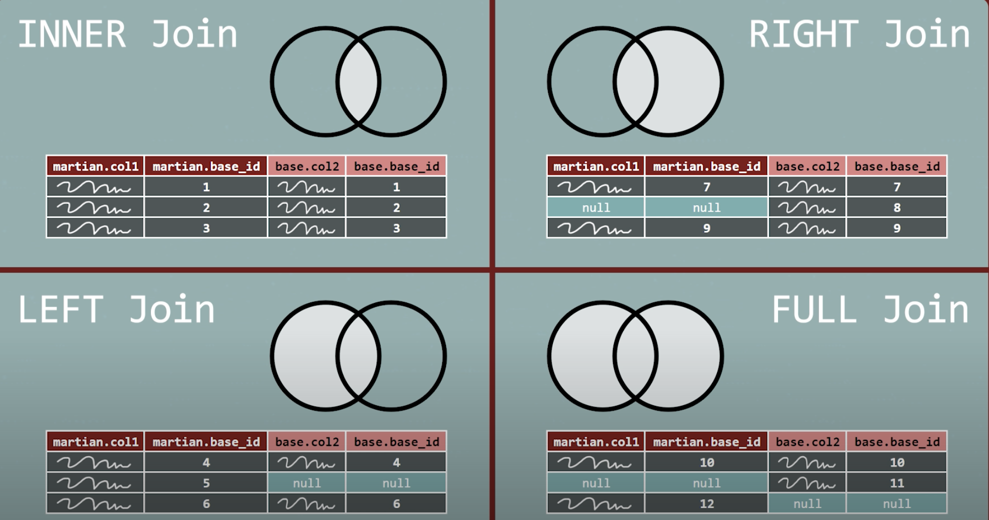

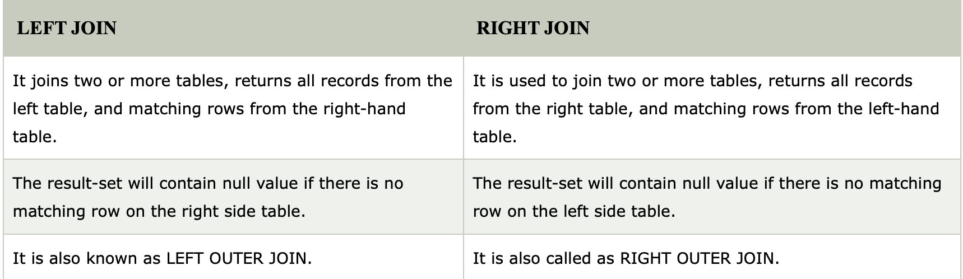

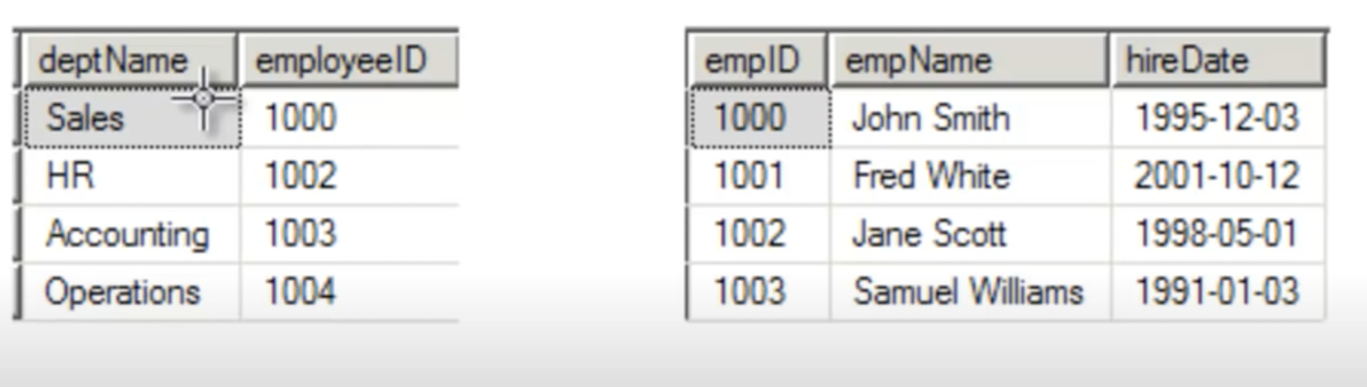

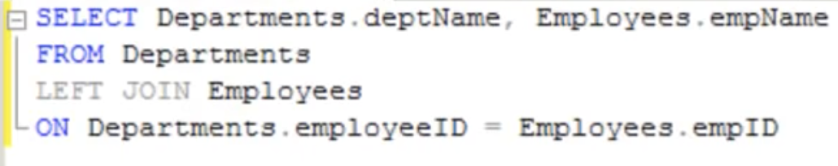

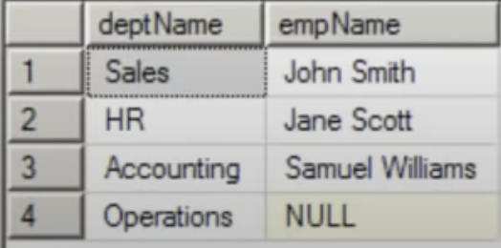

1NF

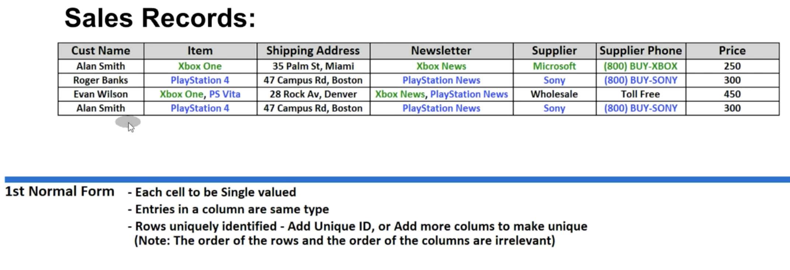

2NF

ALL VALUES ON THE TABLE SHOULD BE CONNECTED TO THE KEY. FOR EXAMPLE, THE ID DOES NOT DEFINE THE PRICE OF A PRODUCT BUT IT IS CONNECTED TO THE USERNAME, ADDRESS AND NEWSLETTER. WE NEED TO CFREATE 2 SEPARATE TABLES

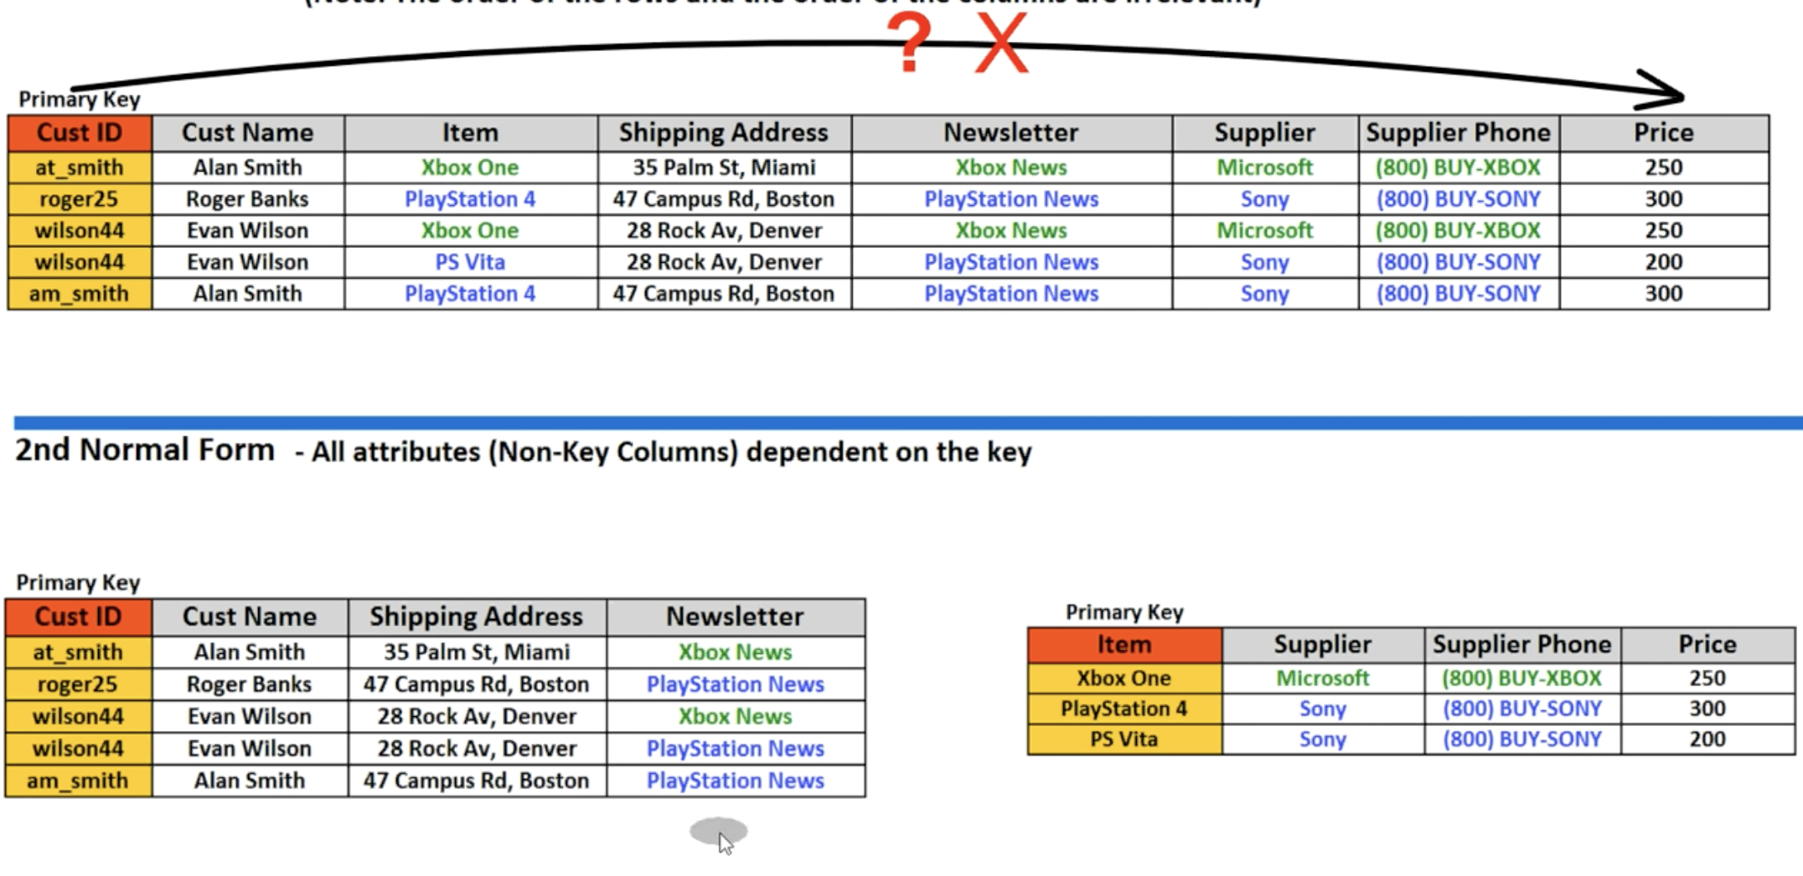

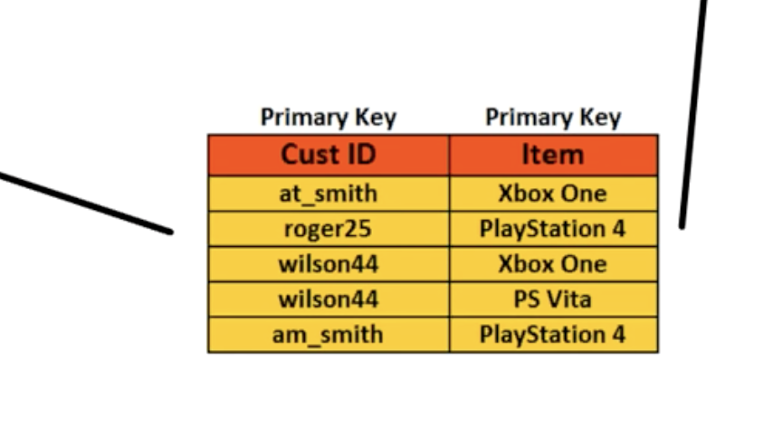

3NF

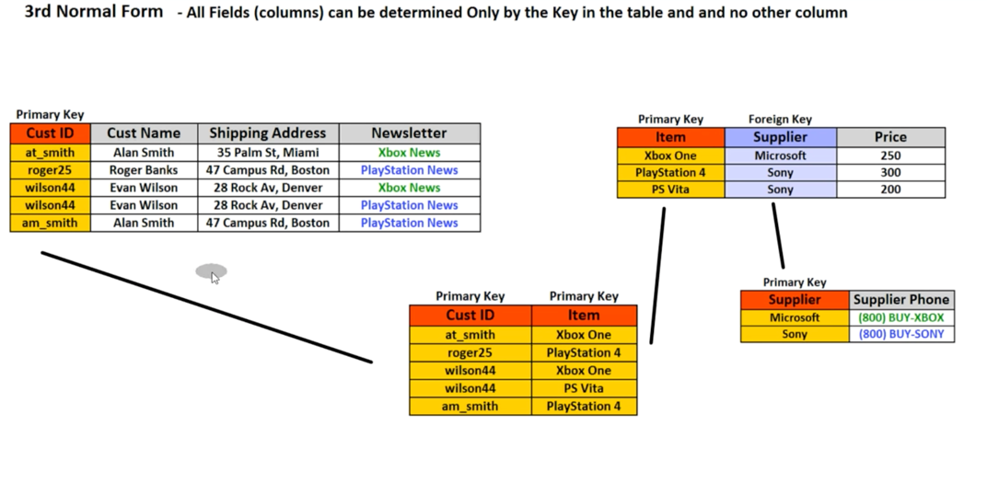

4NF

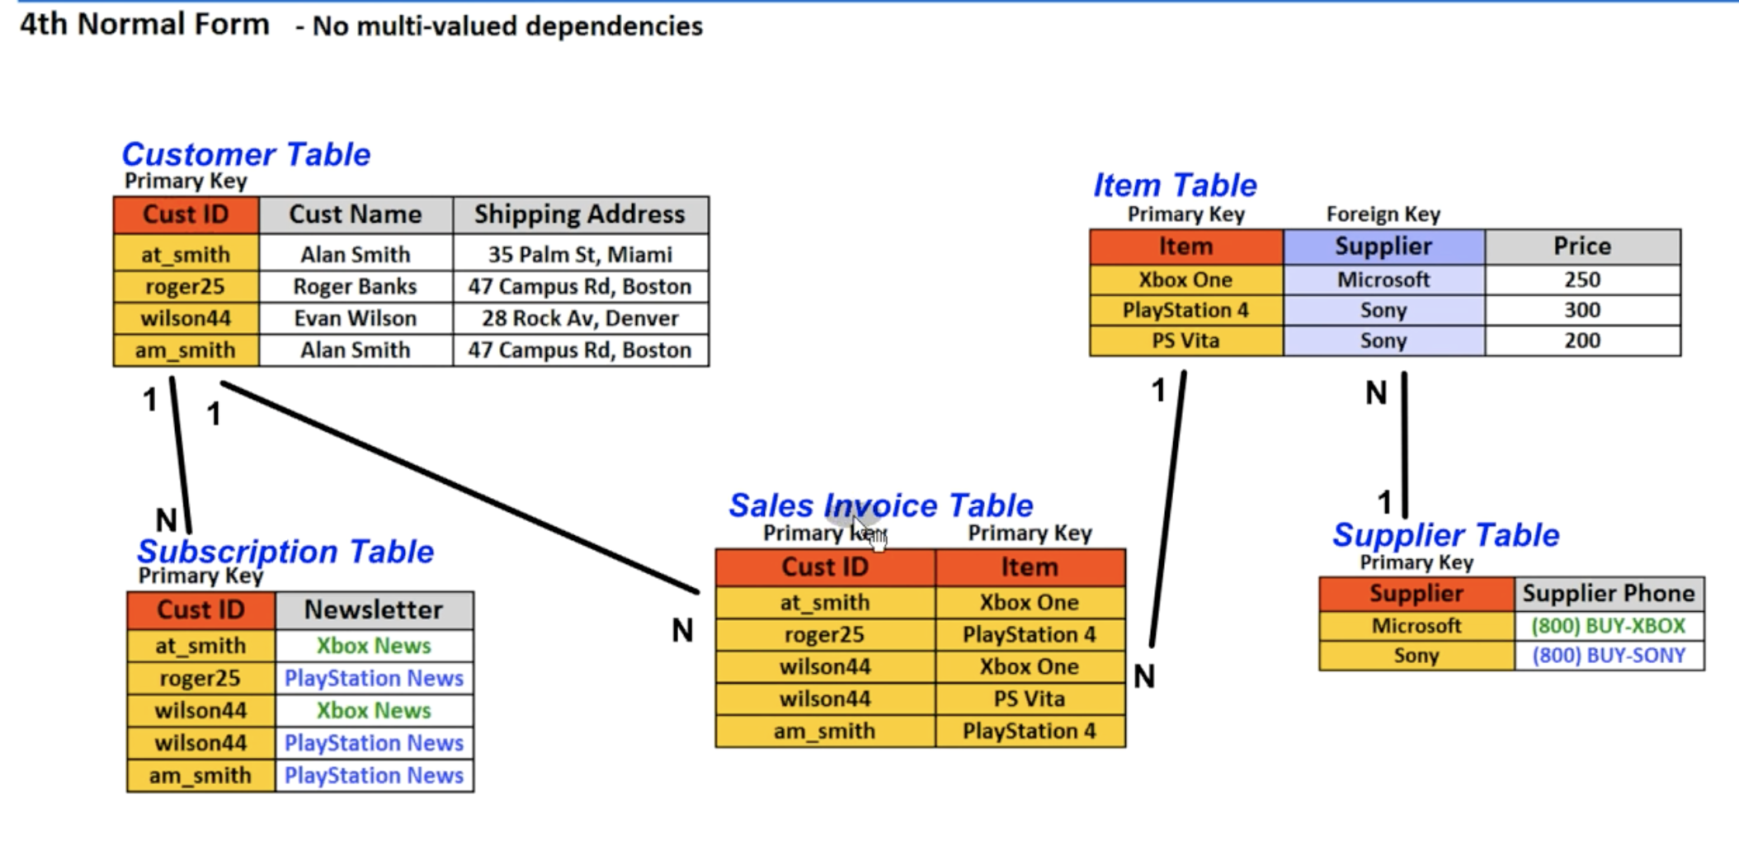

REST or [RESTful API](https://www.mulesoft.com/resources/api/restful-api)

REST or [RESTful API](https://www.mulesoft.com/resources/api/restful-api) design (Representational State Transfer) is designed to take **advantage of existing protocols**. While REST can be used over nearly any protocol, it usually takes advantage of HTTP when used for Web APIs. This means that developers **do not need to install libraries** or additional software in order to take advantage of a REST API design. REST API Design was defined by Dr. Roy Fielding in his 2000 doctorate dissertation. **It is notable for its incredible layer of flexibility**. Since data is not tied to methods and resources**, REST has the ability to handle multiple types of calls**, return different data formats and even change structurally with the correct implementation of hypermedia.

features:

### **Client-Server**

The client-server constraint works on the concept that the client and the server should be separate from each other and allowed to evolve individually and independently

### **Stateless**

REST APIs are stateless, meaning that **calls** can be made **independently** of one another, and each call contains all of the data necessary to complete itself successfully

### **Cache**

Because a **stateless API can increase request overhead by handling large loads of incoming** and outbound calls, a REST API should be designed to encourage the storage of cacheable data

### **Uniform Interface**

The uniform interface lets the client talk to the server in a single language, independent of the architectural backend of either

Design patterns

**Singleton pattern:**

It allows to have only one instance of a class and make this instance global to be able everyone to have access to this single object. the steps you need to follow in java:

1. create a class

2. create a static object of the class

3. make the constructor of the class private

4. create a public function that get the instance of the static object

**Drawbacks**: (find them)

One of the main disadvantages of singletons is that they make unit testing very hard. They introduce global state to the application. The problem is that you cannot completely isolate classes dependent on singletons

